OER STEM Presentation Narration Script

Course: | Open Math | Module: | 6

Scene | Script | Graphic | Animation/Transition  Instructions
1.0 | In this module, you will learn about how to prepare students for rich instruction with OER. | 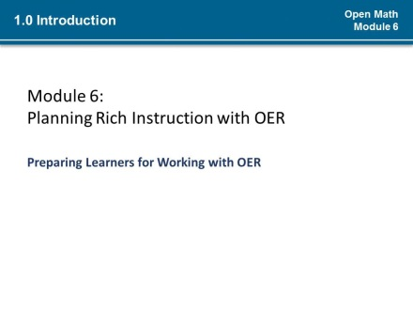
1.1 | (*) You have set a goal for the lesson.  (*) You have identified the OER you will use to meet the lesson objectives.  (*)You may have already decided an instructional strategy for your lesson and (*) begun to modify and supplement the resources you selected. | 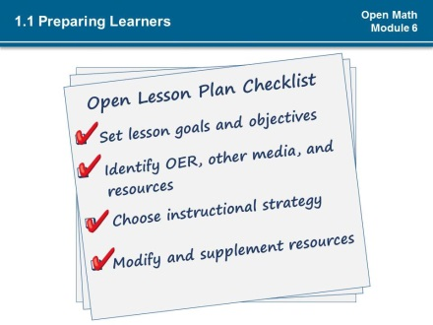 | Animate checkmarks*
1.2 | Now, as you put the finishing touches on your lesson plan, how do you prepare your learners for your open lesson?  To prepare learners for your open lesson requires you to (*1)help them develop strategies to become independent users of Open Educational Resources.  (*2)You will also need to stock your OER Toolkit with the essentials learners will need to participate in your open lesson. | 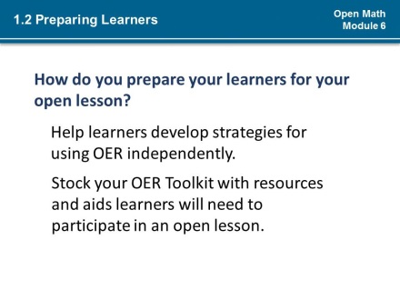 | Animate paragraph beginning “help” (*1)  Animate paragraph beginning “stock” (*2)
1.3 | It may be challenging at first to prep learners for engaging in an open classroom because learners may be unfamiliar with how to search for and identify OER.  (*1)They also may not have the tools or other skills needed to be able to adapt open resources. The strategies for using OER all require creating conditions for use in the learning environment and readying learners to be independent.  (*2) The good news is that as you have progressed through this course and as you have been working on your lesson plan, you have been developing strategies for working with OER and gathering tools that you can share with your learners. | 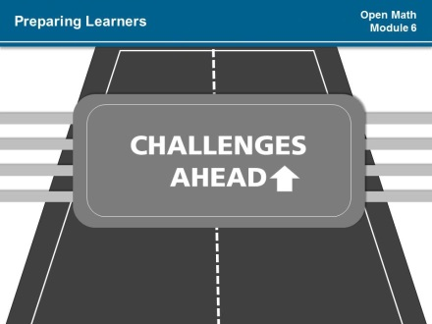  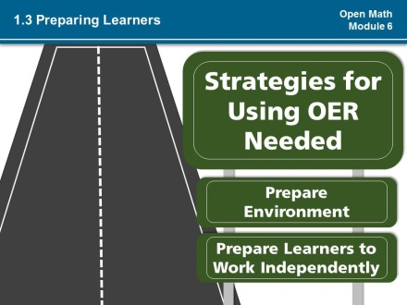  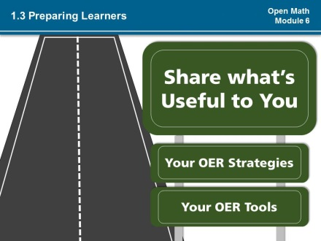 | Transition to strategies for using OER Needed (*1)  Transition to strategies for using OER Needed (*2)  If possible create effect of driving down road for each slide.
2.0 | You’ll recall from previous modules that there are several strategies for using Open Educational Resources with adult learners in an open classroom. Learners can work with others (*1) or independently to create OER (*2) to learn or demonstrate skills and knowledge. They can also create (*3), revise(*4), remix(*5), or share OER(*6). For students new to working with Open Educational Resources, strategies around using OER are very important to develop because you want to involve students in planning objectives and make sure they can find and adapt OER in the ways required to meet objectives for learning and performance.  Supporting students to develop strategies for working with OER can help them to become lifelong learners and provides them with the practical skills to be able to seek out OER and other resources to learn STEM well into the future.  To prepare students to create OER(*1), revise(*2), remix (*3) or share (*4) them, you want be sure to work time into your lesson to explicitly teach the strategies they will need.  Can you think of other uses of OER or associated tasks that might require explicit instruction? | 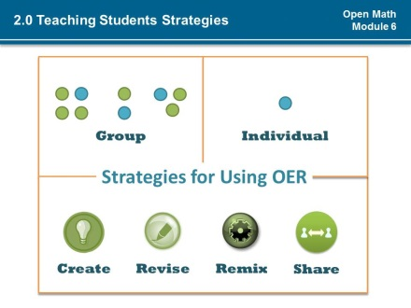 | Pulse each object & word  Group (*1)  Individual (*2)  Create (*3)  Revise (*4)  Remix (*5)  Share (*6)
2.1 | Students in an open classroom are using new skills or skills that they may have already developed but are being asked to apply in a different context. You can use explicit strategy instruction to develop learners’ skills and to engage them in thinking about how to perform complex tasks. When learners are just starting to use OER, explicit strategy instruction may be necessary to ensure students can use the open educational resource as required.  Explicit Strategy Instruction involves just four steps which may be very similar to how you present other complex strategies to your students:  The first step is, explaining what is going on and the strategy.  (*1) The second step is for you to model the learning process - it is simply remembered as “I Do.” (*2) In the third step, “We Do,” you guide learner practice.  (*3) The fourth step is independent practice or “You do.” | 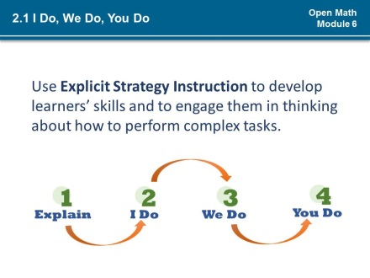 | Wipe arrow from left  Arrow 1 to 2 (*1)  Arrow 2 to 3 (*2)  Arrow 3 to 4 (*3)
2.2 | To summarize:  (*1) You would explain the strategy you are teaching and then model the strategy.  (*2) Next you would guide the whole class through an example and (*3) allow students to practice together. You would work with groups as needed to provide coaching around use of the strategy.  (*4) Afterwards students are assigned independent work. At this point you would provide additional examples for student reference as they work independently and give immediate feedback on student work.  (*5) Remember throughout the four-step process feedback to learners should be immediate and continuous.  Let the skills and needs of your students determine whether you need to use explicit strategy instruction. It may not be necessary to go through all four steps each time you teach an open lesson (*1-4). Once your students are able to use OER, then explicit instruction may not be necessary. (*6) Be prepared however, to model any new concept or skills at least two to three times and individually with students. | 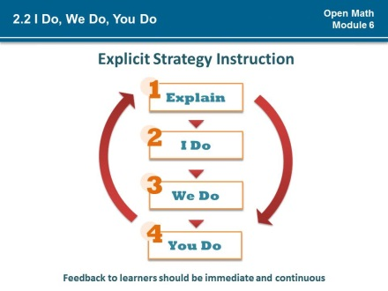 | Pulse Steps 1-4 (*1-4)  Fade in sentence beginning “feedback to learners.” (*5)  Teeter arrows (*6)
2.3 | Once your students are able to find, use and adapt OER comfortably, then explicit instruction may not be necessary. Be prepared however, to model any new concept or skills at least two-three times and individually with students.  Take a moment to review the steps of explicit strategy before moving on. | 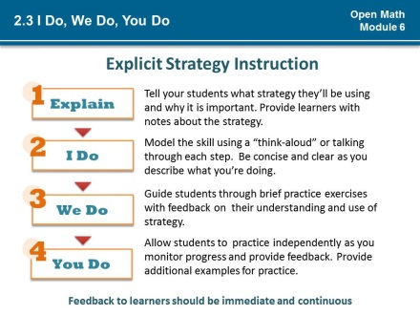 | Immediately after screen loads:  Slide graphic to left  Fade in paragraphs one by one.
2.4 | (*1). Here a few notes to remember about Explicit Strategy Instruction:  - (*2)Always provide learners with an authentic context for learning a skill.  - (*3)Break down the skill into small and logical steps.  - (*4)Illustrate the skill in different ways – e.g. use pictures, words, gestures, vary vocal tone.  - (*5)Frequently ask questions to check for understanding.  - (*6)Provide enough time for students to process information and ask questions.  - (*7)Remember to engage leaners and to encourage them to self-monitor.  - (*8)Explicit Strategy should be student-driven.  (*9) (*10) | 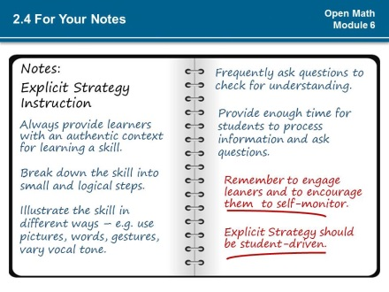 | Animate paragraph by paragraph with a wipe effect from left, by letter. Duration .5 for each animation. (*1-8).  Animate line one from right(*9)  Animate line two from left (*10).
3.0 | Differentiating your lesson is key with OER. This includes supplementing OER as necessary with additional resources and context. Your open lesson can be differentiated by (*1) the content and how students access materials, (*2)by process or how they complete activities and (*3)by the learner products or the work they create. As part of your lesson plan process, you have gathered information that can be used to differentiate your open lesson.  Through observation and review of your students you are probably also aware of differences between your students such as their (*4) readiness to learn, (*5) their learning preferences and (*6) interests.  Explicit instruction can also be helpful in decisions about how to differentiate student engagement with OER. As you provide feedback to students during strategy instruction, you will learn about students’ challenges and comfort level with certain skills that will help you with specific assignments.  See the TEAL Fact Sheet on Differentiated Instruction for more information. | 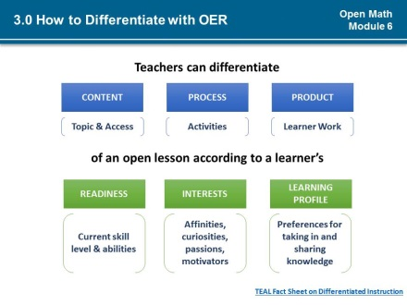 | Pulse together:  Content/topic & access (*1)  Process/activities(*2)  Product/learners work (*3)  Readiness/current skill level (*4)  Interests/affinities, etc. (*5)  Learning profile /preferences (*6)
3.1 | You might use information directly from students, like a self-assessment, to help you to differentiate instruction based on their preferences.  Review the considerations on the screen. Consider what other questions you might add or observe about students to help differentiate assignments with OER | 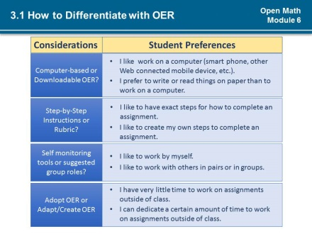
4.0 | No matter what you are asking learners to do with OER in your classroom, every open classroom needs an OER toolkit. Your toolkit contains essential resources for you and your learners for finding, managing, evaluating, adapting and creating OER and strategies for working with them. For example you might want to add the notes shared in this lesson about explicit strategy instruction and considerations for differentiating with OER to your toolkit.  Depending on how you are having learners use OER in your lesson, (*2) you might also include a range of tools and strategies, such as:  - (*3) A way to get internet access  - (*4) A place to share OER with other learners  - (*5) Sites or repositories where students can identify quality OER. You may even provide students with OER.  - (*6) Criteria for evaluating OER, like a modified version of the Achieve Rubrics.  - (*7) Lists of tools for creating, revising and remixing OER  - (*8) A rubric or some other basis for understanding how what they are doing can be assessed.  - (*9) Checklist and job aids, like an OER license chooser and your practices checklist. You want to be sure that the OER and any supplemental resources and instructional strategies you have chosen meet objectives and align with whatever student and teacher practices guide your instruction.  - Finally, think about including in your toolkit tutorials with steps that describe the strategies you will model for your learners | 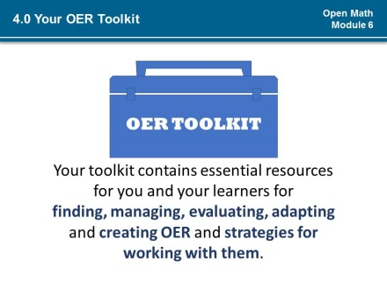  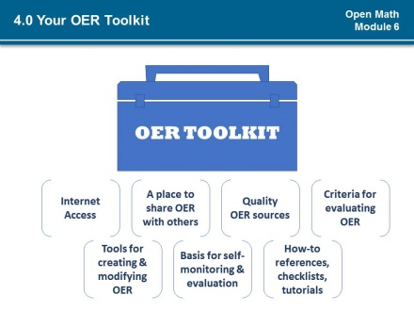 | Transition to next slide (*1)  Pulse description of each tool (*2-9)
4.1 | Review your lesson and think about your plans for using Open Educational Resources with your students. What do you need in your toolkit? What will your students need to complete your open lesson? | 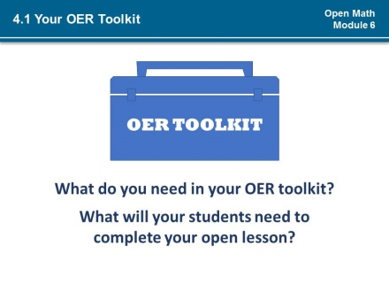
5.0 | (*1)Prepare students for working with OER by teaching them strategies and sharing with them useful tools and resources. (*2) (*3)  (*1)When asking students to do something new or complex remember the four steps of explicit strategy instruction: Explain, I Do, We Do, You Do. Start slow – use OER as appropriate based on learners’ needs and abilities. Work on developing abilities of students to use OER (move students towards open learning) – even if you do not use the full range of strategies possible with OER, these skills are invaluable to lifelong learners. (*2) (*3)  (*1)There are many things that can be done with OER that can differentiate your OER lesson so that a variety of learners can participate in your open lesson. You can differentiate the content, process, or learner products of your lesson based on learner profiles, their readiness and interests. Use information about your students prefer to learn to create varied and rich opportunities for learning and sharing knowledge. (*2) (*3)  (*1)Build and share your OER toolkit. Rule of thumb is if it is useful to you then it will probably be useful to your learners. Some of the tools you will add to your toolkit might be specific to using OER, but all will support independent lifelong learning. (*2) (*3) | 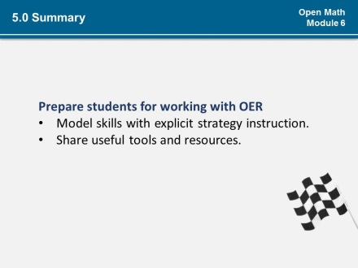  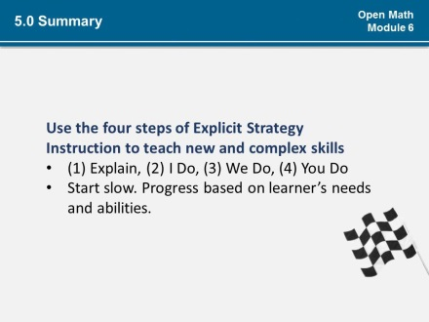  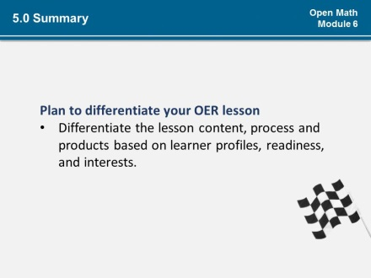  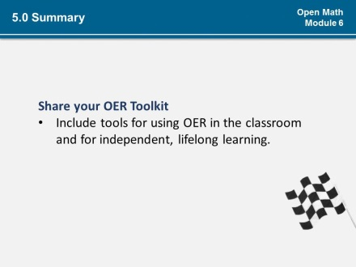 | Text flies in from the left as slide loads (auto). (*1)  Flies out to the right as slide on click. (*2)  Transition to next slide (*3)  Note on each slide: Replace flag with flag from Course 1 Summary
5.1 | Consider these questions as you work through the activities for this module(*1):  (*2) What do you know about your learners’ readiness, interests, and learning preferences?  <<Pause>>  (*3) How can they share this information with you?  <<Pause>>  (*4) How can you differentiate the content, process, or products for your open lesson?  <<Pause>>  (*5) Are there any changes needed to your lesson plan at this point? | 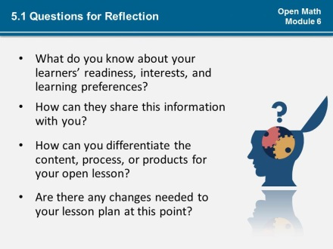 | Float in question mark (*1)  Fly in questions (*2-5)

