OER STEM Presentation Narration Script

Course: | Open Math | Module: | 5

Scene | Script | Animation/Transition  Instructions | Graphic
1.0 | This presentation covers tips for selecting OER for your lesson. | None | 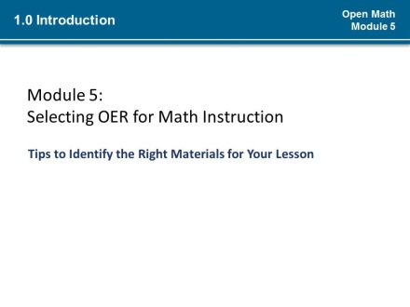
1.1 | (*1)There are thousands of Open Educational Resources available to you to adapt and share with your students to present new concepts, provide practice, and your help students demonstrate their understanding of a topic. You have some ideas about how you and your students might use OER, but how do you pick the right OER out of the many open materials teeming the Web? (*2)  To select OER for instruction you must have a strategy for locating OER and determining their suitability for your lesson.  (*3)It may be overwhelming to think about narrowing down so many choices to just a few or even one, but by analyzing your learners’ needs and planning your lesson goals, you have the information you need to successfully do this. You have also been introduced to several tools already that can help with finding the right OER. Now in this lesson we will discuss how to use those tools and a few a new tools and strategies to find and select quality OER. | Fade in image in background very slowly as slide loads. (*1)  Fade out background image as OER appears, then arrow flies in from bottom (*2)  Transition to next slide in series. (*3) | 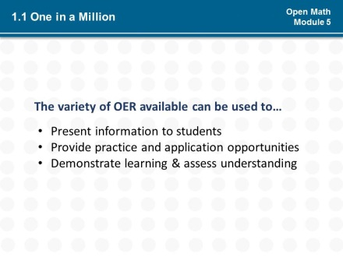  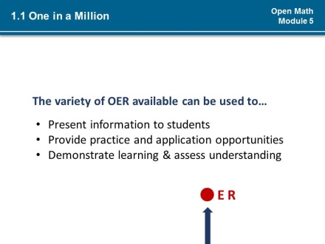
1.2  1.1 | Now that you have set a goal for the use of an Open Educational Resource in your lesson back in Module 4, you must find one that will meet the goals you have already set for your lesson. When finding and reviewing OER, you notice there are many different OER types out there; a lot of good ones and a lot of not so good ones. In this open environment, it is important that you evaluate OER for quality and suitability for your lesson. |  | 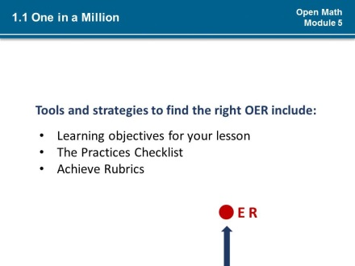
2.0 | The process for identifying quality OER for your lessons involves:  - Being adept at finding relevant OER;  - Using criteria to determine OER quality;  - Reporting on quality; and  - Adapting or revising and remixing materials | None | 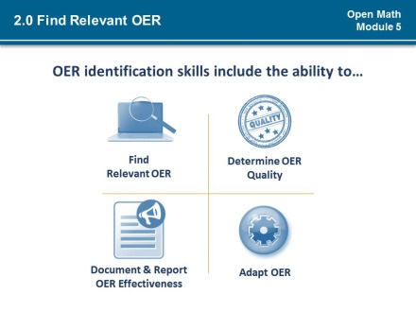
2.0 | The first thing you want to do when preparing to find resources for your open lesson is to make sure that you can distinguish Open Educational Resources from resources that are not open. In an open classroom you will be limited by what you can do with a resource if it’s not open.  Which of the resources shown have the rights associated with OER?  <<Pause >>  (*1) To ensure the resource is an OER, check the licensing and read the fine print. A Creative Commons license of some sort likely indicates that the resource is open as some level for use in your open lesson. There are resources which permit adaptations by someone other than the author which may not have one of the Creative Commons licenses attached, therefore it is important to always read licensing language and usage terms.  With practice, you will become very comfortable zooming in on the licensing terms for any given resource. As you sort OER from non-OER, be sure to keep aids, like the Creative Commons license aid, nearby for reference. This will help you determine whether the OER can be used as you planned in your lesson. | Note error on first slide image --- the OER and NOT OER labels should not be shown.  Transition to next slide (*1) | 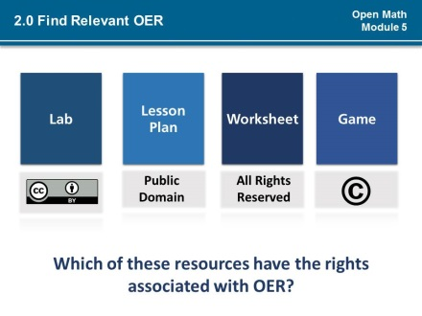  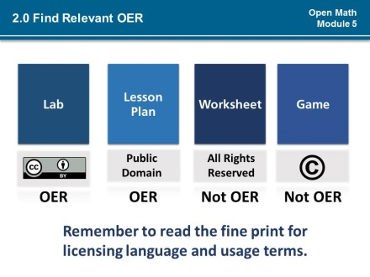
2.1 | The more you know about how you want to use an Open Educational Resource in your lesson, the better you will be able to filter your search results. (*1)  Because you started your lesson planning with first determining the goals for your (*2) lesson and objectives for use of OER, you have an idea of the type of permission you will need for that OER.  (*3) You may also know what format or media type you need, what standards or practices to integrate, and learner level to target as well. Does your lesson plan require an OER for an assessment? Will text-based resources work for your lesson or do you need a simulation? Does it need to be accessible on a mobile device? Can higher or lower level resources be integrated into your lesson?  These specifications are the beginning of great filtering criteria for your OER search results. | Transition to next slide in sequence (*1)  Fade in section that begins “Filter…” (*2)  Fade in section that begins “In addition to other information” (*3) | 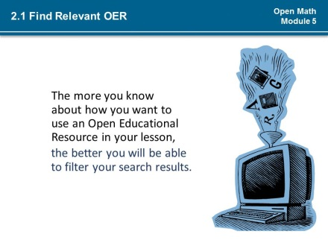  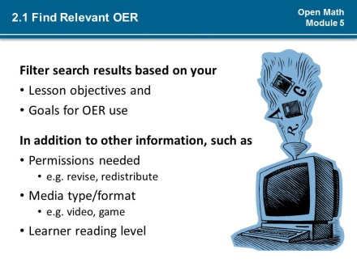
2.2 | In the Open Your Classroom Course you learned about how to develop effective search queries and how to use the advanced features on YouTube and Google to find open licensed materials to fit your key terms. These searching strategies also apply to many of the OER repositories. Review the video, if you need to, and practice searching and filtering your results until you are comfortable finding OER. |  | 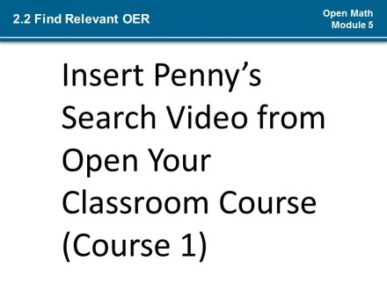
2.3 | Another strategy for finding Open Educational Resources is not to search for OER, but to have them come to you!  This can be done over time by creating your own personal network of trusted OER sources, which includes OER repositories, OER informational sites, and other OER users’ resources lists.  Identify trusted sources of OER, such as math bloggers who post high quality Open resources, social bookmarking accounts that belong to educators’ whose OER choices resonate with you, or well-known publishers of evidence-based OER.  Engage with the open community to stay abreast of resources. Participate in discussion forums. Subscribe to YouTube channels dedicated to OER use. Join mailing lists. Create RSS feeds or alerts which automatically notify you when a new resource has been shared. | If possible, slide “Become an OER Magnet” towards magnet image on slide open. (*1) | 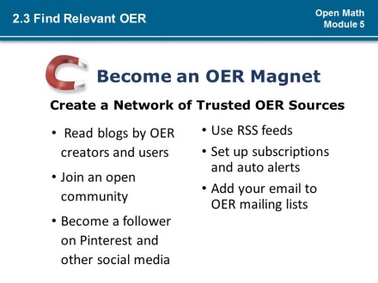
2.4 | You might identify an excellent resource that you would like to adapt for your lesson that may not be open simply because no one has asked. If there are materials that you would like to use in your open lesson, but cannot because they are not openly licensed, (*1) then ask the author to publish the content as an Open Educational Resource. You may need to explain what an OER is, so be prepared to speak to the benefits of making the resource open. A great starting point is explaining how you intend to use the resource in your open lesson! | Transition to next slide in sequence (*1) | 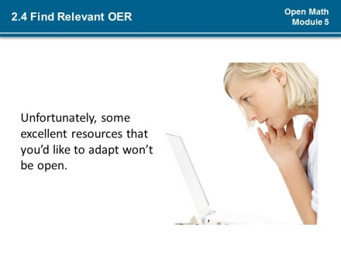  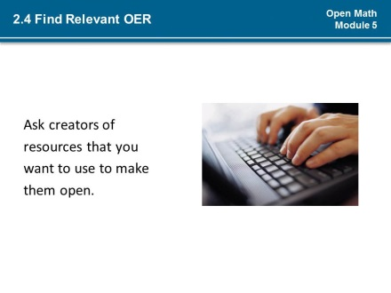
3.0 | Any Open Educational Resource you find must be assessed for both quality and suitability for your lesson. Many OER are in fact very high quality, offering robust and engaging learning experiences, however they may not meet the objectives of your lesson or be appropriate for your learners. Again, this is why setting goals for the use of the OER in your lesson is so very important. | none | 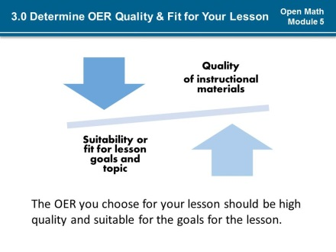
3.1 | (*1) Keep these four considerations in mind as you select Open Educational Resources for your lesson:  - (*2) Is the content relevant? Are the activity & assessment design appropriate to meet learning objectives?  - (*3)Will the resources foster student learning and engagement? Is the resource suitably challenging and enjoyable to use to engage learners and promote development of student practices?  - (*4)Is the OER in a usable medium? Is it accessible and easy to use for all learners? Is the information presented accurate, clear and relevant to learners? Can your or your students feasibly adopt the OER or adapt it if it needs adjustments for personalization, relevancy, and localization?  - (*5)What do users of the OER say about its quality? What types of comments do users share about their experience with the OER? How does the OER rate on an evaluation rubric? | Animate numbers one-by-one (*1)  Animate questions (*2-5) | 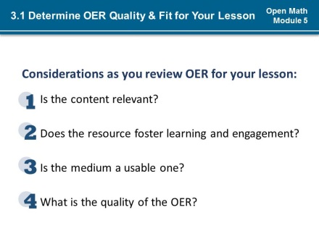
3.2 | In the Open Your Classroom course, you were introduced to the Achieve rubrics, which can be used to assess quality of Open Educational Resources.  Achieve, a nonprofit educational reform organization, partnered with OER Commons to make its OER rubrics available online. They can be used across content areas and different OER types to evaluate the smallest or largest learning resource – everything from a single worksheet to an entire course. The eight rubrics rate the potential effectiveness of an OER on a 5 point scale to assess quality, usefulness and alignment to the Common Core State Standards. (*1) By the way, the Achieve Rubrics also happen to be OER. | Fade in CC BY icon (*1) | 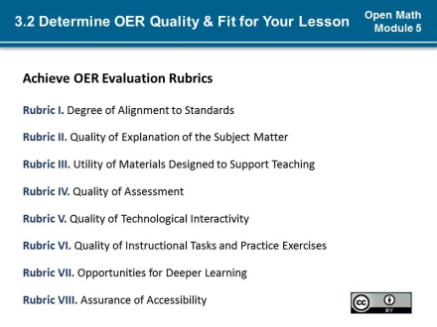
3.3 | The rubrics are very useful in weighing the quality and fit of an Open Educational Resource for your classroom. Although each rubric does not fit every potential use of OER, you will want to use as many of the rubrics as apply. For instance Rubric 3, which is designed to assess lesson plans, may not be appropriate for rating an interactive OER, like a game.  (*1) For our first consideration: “Is the content relevant?”, Rubrics 1, 2, 3, and 4 are useful.  (*2) Rubrics 5, 6 and 7 apply to our second consideration: “Will the resources foster student learning and engagement.”  (*3) Rubrics 2, 5, and 8, might help you to determine the usability of the OER for your learners.  (*4)Teachers using OER use these rubrics and share them on OER Commons so that educators like you can benefit from their experience to make informed decisions about which OER to use in your lesson. When deciding on an OER to use, be sure to check OER Commons to review any rubrics completed by other users and comments that explain their ratings. A feature in OER Commons and of other open communities is that you can contact another member to inquire for more information. | Animate in rubrics:  Rubrics I, III, IV (*1)  Rubrics I, III, VII (*2)  Rubrics II, V, VIII (*3)  All Rubrics & OER User Evaluations (*4) | 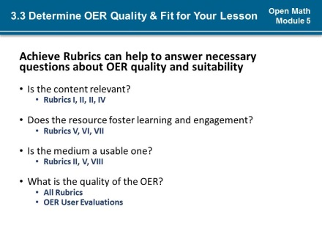
3.4 | Another tool you have available to you is the Practices Worksheet, which you began to customize earlier in this course.  As you think about these questions and structure the entire learning experience to meet your goals, the math practices worksheet will be helpful to you to (*1) keep track of which mathematical practices are being developed by the OER. (*2) Keep a record of what the OER actually covers in relation to your goals and create a space to record notes, additional materials required and other comments about how the OER can be used. | Pulse:  Begins “Keep” (*1)  Begins “Record” (*2) | 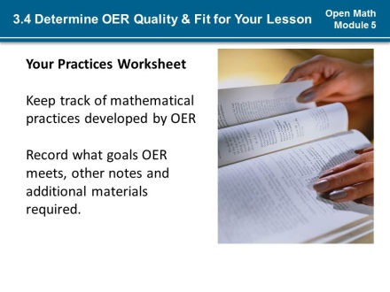
4.0 | While others’ ratings of Open Educational Resources and user comments might be helpful in deciding whether you will use an OER for your lesson, keep in mind that those ratings are based on the unique instructional context of the other user. (*1) The best assessment of an OER for your lesson is going to be yours. As you sort through OER for potential use in your lessons, take time to rate any OER that are promising. An OER may not be the best fit for your current lesson, but it may work well for other lessons you plan in the future. You may come across an OER that you would like to use but that may not be work for any number or reasons. (*2) Along the same lines, you will want to evaluate and document any OER that you have used with great or only mixed results.  Save these OER to your personal OER repository along with your notes and comments to inform future searches for open materials. Use the Achieve Rubrics to rate the OER and document what you liked or did not like in your detailed comments. The OER may prove to be a perfect choice in another context, for instance when you to revise it or remix it with another resource or use it when the learners’ needs are different.  (*3) Over time, you may notice patterns in the open types of resources that work for you and your students, which may help to further refine your selection criteria. | Pulse:  Begins “Include” (*1)  Begins “Document” (*2)  Begins “Review” (*3) | 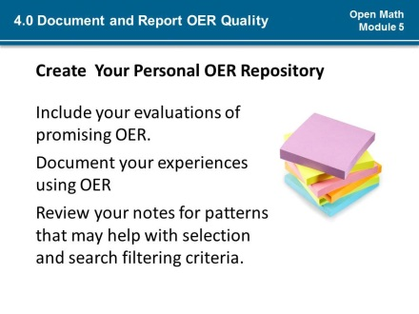
5.0 | The quality of Open Educational Resources varies wildly and can make identifying and selecting OER challenging. This challenge also creates opportunity to work collaboratively with students, other teachers, and across disciplines without restriction to improve learning and teaching materials for all involved. When you cannot find the exact OER you need, revise or remix the OER that comes closest to what you need.  You can edit the content or pair the OER with other open resources to create an OER that will meet the needs of your lesson. Then share your revised OER with the open community. Your updates to make OER adult learner oriented will be appreciated by all the learners and teachers who seek out OER in the very same places where you look to find quality materials for your instruction. | None | 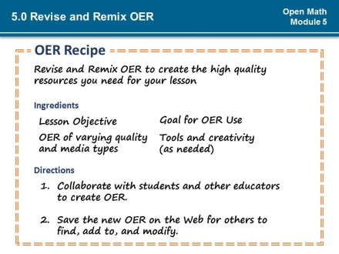
5.0  6.0 | Quality materials are important to delivery of your open lesson. Although identifying and selecting quality Open Educational Resources can be challenging, there are many tools at your disposal to help you find the OER you need. Selection criteria, like the Practices Worksheet and the Achieve rubrics can help you to decide whether an OER is ideal for your lesson and what, if any modifications are needed to prepare the OER for use by your students.  (*1) By evaluating and improving OER you add value to them and ensure quality of materials for your lesson.  (*2) Finally, remember how valuable teacher evaluations and user comments are to your search process. Give back to the OER community by documenting your OER reviews and sharing them in your OER networks. | Transition to next slide (*1-2) | 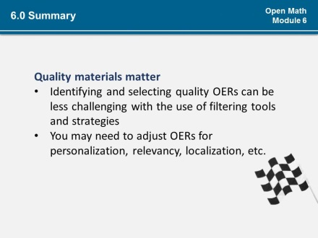  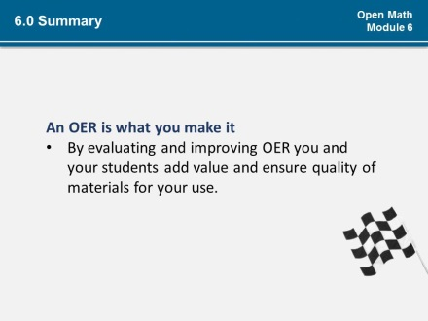  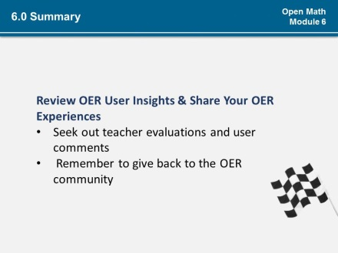
5.1  6.1 | (*1) Consider these questions as you work through the activities for this module:  (*2) What is your process for finding Open Educational Resources?  <<Pause>>  (*3) How can you organize OER and other instructional resources?  <<Pause>>  (*4) How can you prepare students for finding OER?  <<Pause>>  (*5) How can you prepare students for determining the quality of an OER? | Float in question mark (*1)  Fly in questions (*2-5) | 