OER STEM Presentation Narration Script

Course: | Open Math | Module: | 3

Scene | Script | Animation/Transition  Instructions | Graphics
1.0 | In this module we will review the basic components of a lesson and the lesson planning process. After this module you will be able to use these frameworks to integrate Open Educational Resources into your lessons. |  | 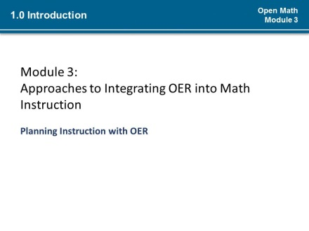
2.0  1.1 | Sometimes a lesson is driven by what is necessary to teach or what students need to know or be able to do; (*1) sometimes a resource may inspire how you deliver a lesson. (*2)However you arrive at a lesson concept, you must create a plan to meet the goals of the lesson.  When you have a process in place for making decisions about how you will use Open Educational Resources in your lesson, you will be able to effectively use OER for students with different needs and integrate more open strategies into your teaching. Thousands of teachers are using OER to enrich and enliven math instruction and you can too, with just a few modifications on the basics of planning good instruction. | Pulse:  Learning objectives (*1)  OER (*2) | 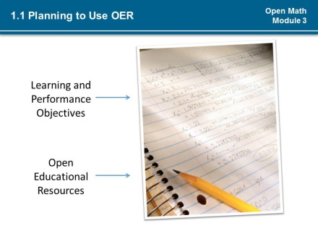
3.0  1.2 | You are already integrating resources into lessons and likely have an approach for doing that, which you have refined over time. As a good educator, you plan a lesson before delivering it. (*1) You determine a topic and the desired objectives for students, and (*2) identify ways you and your students will know that those objectives have been met. (*3)Your lesson plan helps you to organize your strategies for meeting the objectives of your lesson.  Incorporating Open Educational Resources into your lessons does not have to be different from how you are already using other resources for teaching, (*4) except that you must take into account how leveraging the 5Rs of OER. Remember the 5Rs refer to the permissions associated with OER. They are: revise, remix, reuse, redistribute, and retain. | Pulse:  Establish lesson objectives (*1)  Identify assessment strategies (*2)  Determine instructional strategies (*3)  Switch to next slide/Bold “how OER will be used to meet objectives” (*4) | 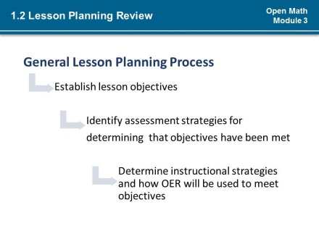  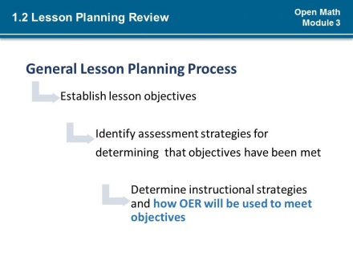
4.0  2.0 | The nature of Open Educational Resources raises some new considerations and opportunities for instruction. Although some of the approaches associated with open pedagogy are very innovative, they are grounded in evidence-based instructional practices, such as differentiated instruction (*1) and Universal Design (*2) for Learning, which help to ensure knowledge transfer and application – all of which require lesson planning. | Pulse:  Differentiated Instruction (*1)  Universal Design for Learning (*2) | 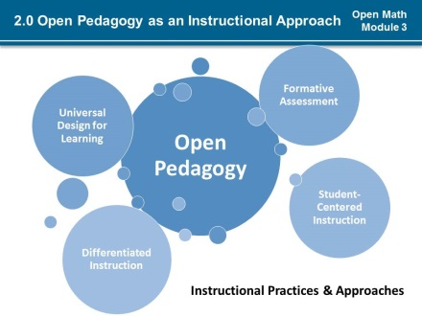
5.0  3.0 | Thoughtful lesson planning is key when using OER for two important reasons:  (*1) First, it takes time and planning to map out how the 5Rs of OER can be leveraged to utilize OER for instruction to open your classroom.  (*2) Secondly, many of the open resources you will use in your lessons will be multi-media, which experts advise requires lesson planning to be used effectively.  (*3)For these reasons, most of this course will focus on the planning stage of lesson planning, where the focus is on defining objectives, teaching and learning strategies, activities and materials, and determining evaluation strategies.  (*4)The very first steps in planning your lesson is to set student learning objectives for the lesson and for the open educational resource and to determine how your students will demonstrate that they have met the objectives. | Show numbers (*1-2)  Transition to next slide in series (*3-4) | 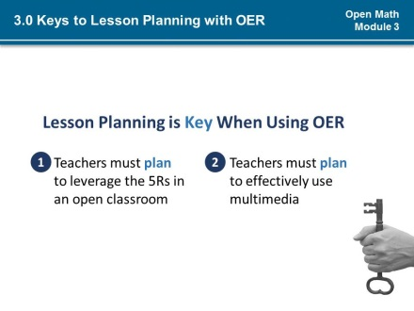  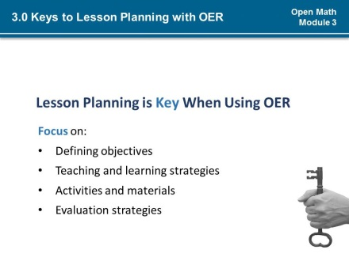  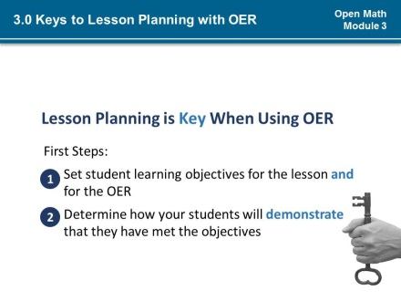
6.0  4.0 | WIPPEA (WHIP-PEE-AH)– Warm Up, Introduction, Presentation, Practice, Evaluation and Application - is a model for lesson planning developed by education theorist, Madeline Hunter, where the components of the lesson plan build on one another. A well-chosen OER can be used for any component of a lesson to make it more open.  You may refer to these components differently, but generally the components of complete lessons do not vary from this basic structure.  This is true even when the delivery mode for the lesson or the setting or medium for implementing the lesson varies. You will hear about a few different delivery models next. | Pulse each lesson component in chart when slide opens | 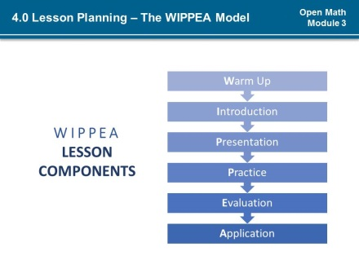
6.1  4.1 | For instance, in a traditional classroom, you may do the warm-up, introduce objectives and present new information for the lesson during face-to-face class time. Then you might assign activities for additional practice for learners to complete outside of the classroom. And next, you would evaluate the students’ work before challenging them to apply the information acquired in a new context. |  | 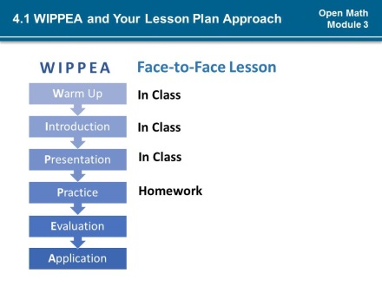
6.2  4.2 | In a flipped delivery model, you may have students independently review new information and use classroom time for answering questions and supported practice, evaluation and application. |  | 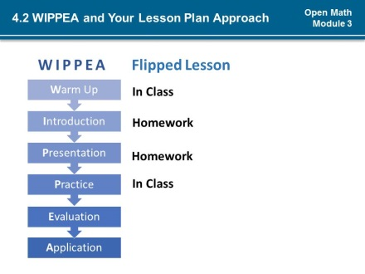
6.3  4.3 | The WIPPEA structure works for face-to-face classroom instruction, flipped lessons, as well as student independent study and blended online and face-to-face lessons. No matter the instructional delivery format, the components of any complete lesson are generally the same and build on each other in the same WIPPEA flow.  Take a moment to familiarize yourself with each of the components of the WIPPEA lesson model and note any similarities to your typical lesson structure and ways you might use an OER to implement that particular component of a lesson. |  | 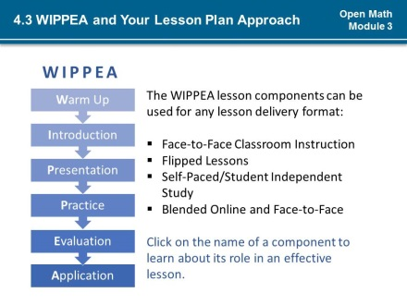
7.0  5.0 | Your plan for developing the WIPPEA components of your lesson is informed by your objectives, your evaluation and assessment approach, and by what your students need to know and be able to do. (*1) But, what informs your decision about which Open Educational Resources and other materials you will integrate into the lesson to support student learning, exploration, and their application of concepts and skills? | Animate question to fly in from bottom (*1) | 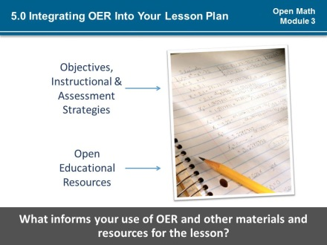
5.1 | NO SCRIPT | User should be able to navigate within this section by clicking on boxes. | 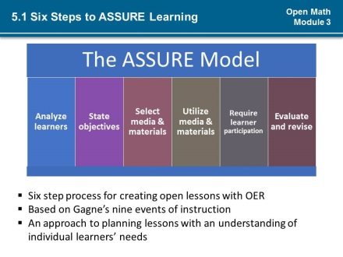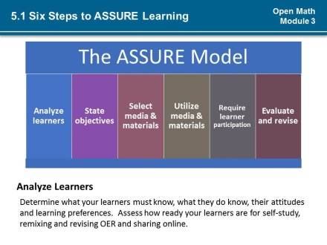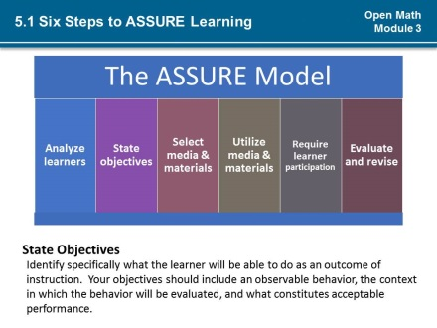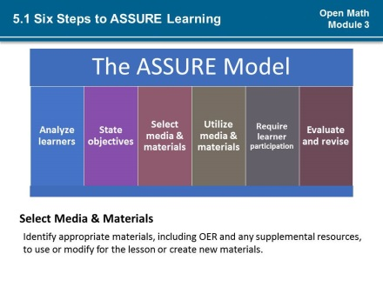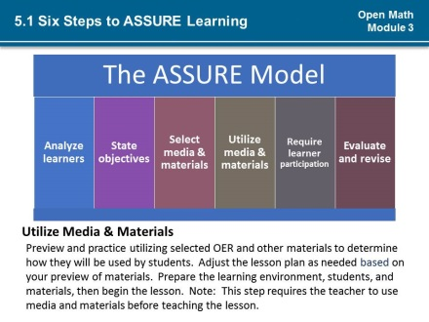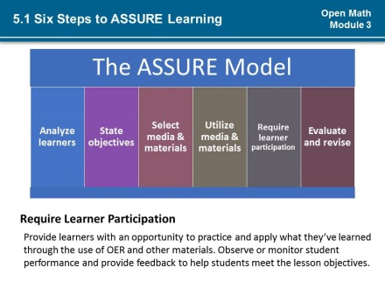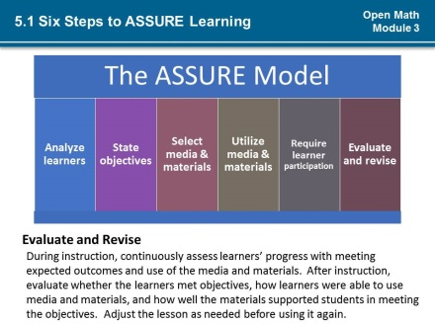
8.0  6.0 | Math and OER expert, Eric Milou developed a WIPPEA lesson with OER using the ASSURE model. Read about his lesson planning process using the ASSURE model or press play to hear him discuss how he planned his lesson. |  | 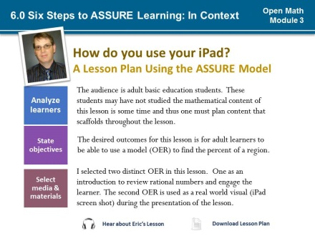  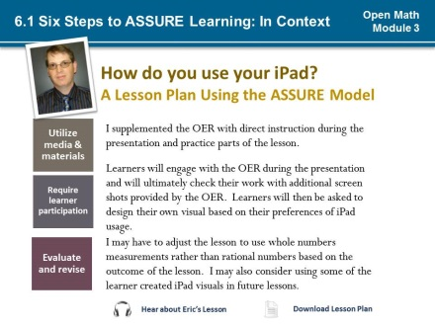
9.0  7.0 | Beginning with the end goal in mind and developing a plan to effectively use instructional strategies and materials to meet those goals is just as important with lessons that use OER as it is with any other lesson. Many OER are very robust – and may even appear as complete lessons - but these built-in features do not replace the effort required of you to plan lessons. When integrating OER into your lesson plans, it is important to tie the use of the OER to your objectives and select appropriate materials to leverage the 5Rs.  (*1) The WIPPEA lesson structure and ASSURE model for integrating multimedia resources into lessons are helpful in that they give us strategies to design lesson with Open Educational Resources. Keep in mind that these models and frameworks are fluid and can be adjusted to reflect the realities of your classroom and your unique instructional context.  (*2)The steps to lesson planning are not always linear, in fact, planning is continuous and iterative. Likewise, lesson planning with OER does not have to occur in the exact order presented in the ASSURE or WIPPEA models. The main takeaway for this presentation is that the considerations presented in each of the frameworks are important in planning your open lessons. | Transition to next slide (*1-2) | 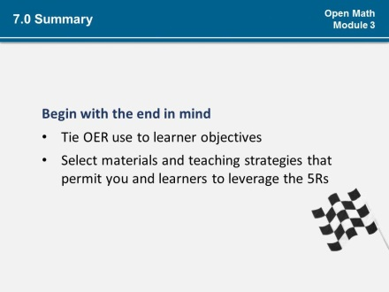  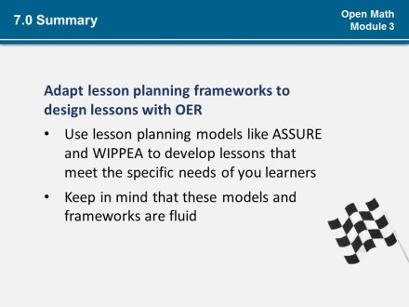  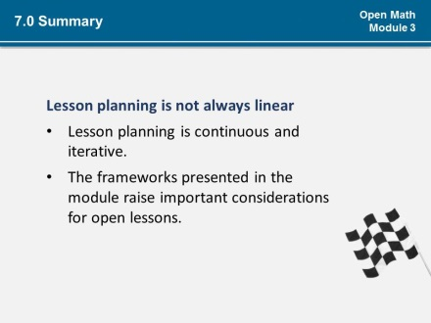
9.1  7.1 | (*1)Consider the questions on the screen as you work through the activities for this module.  (*2)What is your general process for planning and delivering instruction?  <<Pause>>  (*3)How much is instruction driven by OER selection or your lesson plan?  <<Pause>>  (*4)What approach would you use to select and integrate an OER into instruction?  <<Pause>>  (*5)How would you remix or revise ASSURE to create an approach that works for you and your learners?  <<Pause>>  (*6)In what ways, if any, does the information thus far change your practice? | Float in question mark (*1)  Fly in questions (*2-5) | 