OER STEM Presentation Narration Script
Course: | Open Math | Module: | 2

Scene | Script | Animation/Transition Instructions | Graphics
1.0 | In this module, you will learn about some of the instructional practices associated with OER use that are transforming teaching, learning and sharing. |  | 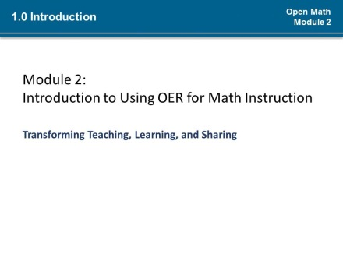
1.1 | Open Educational Resources are shifting teaching and learning practices (*1) beyond providing no-cost and freely reusable content and resources for instruction.  OER, by virtue of the rights associated with them, are poised to change the way teaching and learning occur in adult education. (*2) OER allow teachers to create and share free resources with students and other teachers, identify high quality materials to adopt or adapt, transform or reorganize for their instructional purposes.  The various teacher uses of OER are transforming education, but OER are also transforming how students learn. Like many educators and students are discovering across the world, you can use OER in ways that you cannot use materials with restrictive copyright licenses to facilitate the development of student practices and prepare students for lifelong learning.  (*3) Educators, like you, are taking advantage of the freedoms associated with OER to partner with students to create enriching and meaningful learning experiences. | Transition to next slide(*1-3) | Start with this slide:  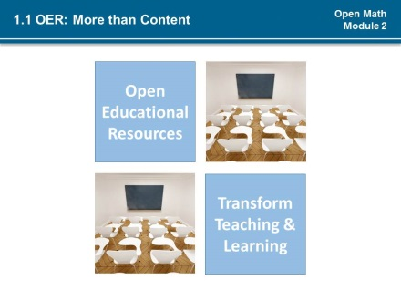  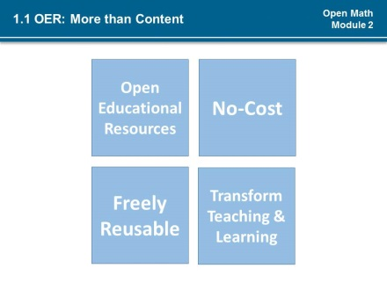  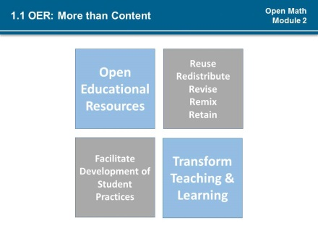  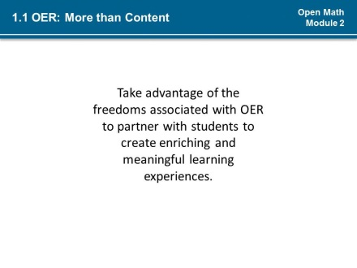  Open Pedagogy
2.0 | The set of instructional strategies and teaching and learning practices associated with the R’s of Open Educational Resources are referred to as open pedagogy (PED-A-GO-GEE). These are practices only possible in the context of the free access and reuse, revise, remix, redistribute and retain permissions that are characteristic of OER.  According to David Wiley, OER expert, (*1) the assignment is impossible without the permissions granted by open licenses. | Transition to next slide (*1) | 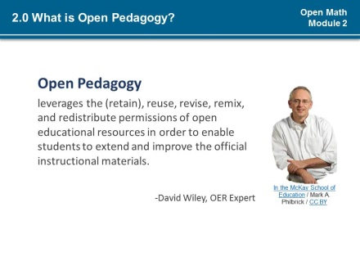  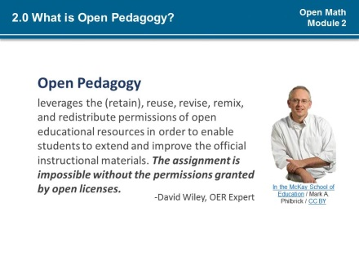
2.1 | Sharing and adapting open educational resources is impacting teaching practice and student learning. (*1)Open pedagogy takes students from isolation to sharing and collaboration, (*2) from consuming to creating, and from (*3) generic to personal. | Transition to next slide (*1-3) | 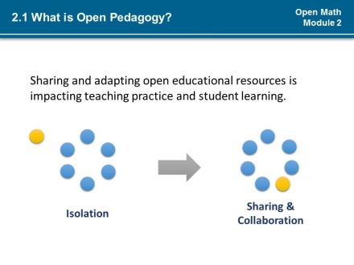  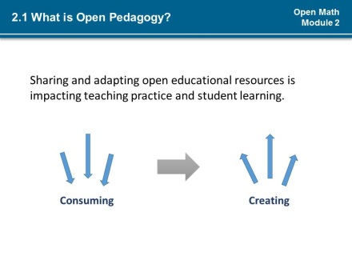  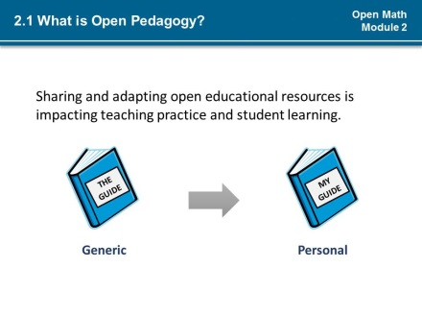
2.2 | To open your classroom with open pedagogy involves implementing strategies that require student use of OER, student contribution to lesson and resource development and sharing between students and teachers – essentially, students and teachers work in an open network to reuse, revise, remix, and redistribute OER to develop desired skills and meet learning goals. |  | 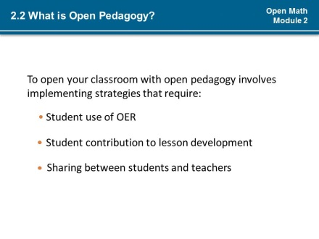
2.3 | When students reuse, revise, remix, and redistribute Open Educational Resources to develop desired skills and meet learning goals, they are thinking and learning at the highest levels of Bloom’s Taxonomy, a scale which organizes learning objectives in order of increasing complexity. In an open classroom students are creating knowledge while (*1) evaluating, analyzing and applying their understanding of concepts. | Transition to next slide (*1) | 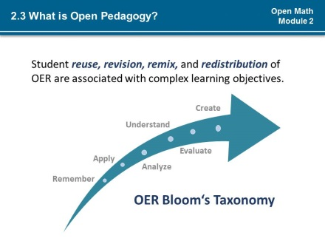  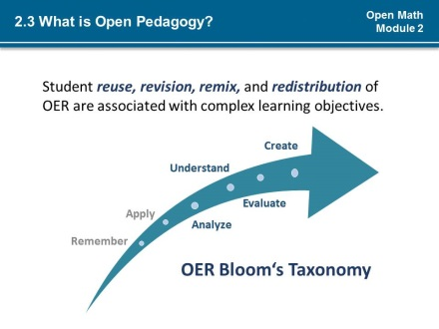
3.0 | Open pedagogy is just one of several approaches to teaching adult learners and can be used to open your classroom alongside other approaches you are already using. For instance, involving students in the selection of Open Educational Resources makes learning student-centered (*1) by allowing learners control over the learning process.  Student use of OER can support implementation of Universal Design for Learning principles (*2), facilitating lesson designs that offer varied and flexible ways for students to learn and demonstrate understanding.  Likewise, differentiating (*3) or adjusting instruction according to learner needs is facilitated by the availability of Open Educational Resources and the ability of teachers and learners to adapt resources to address their particular needs and interests. | Pulse:  Student-centered instruction (*1)  Universal design for Learning (*2)  Differentiated Instruction (*3) | 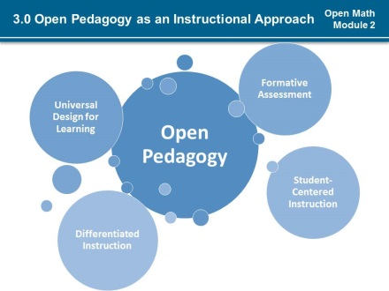
3.1 | Like student-centered learning, universal design for learning, differentiated instruction and other instructional approaches used to teach adults, open pedagogy complements adult learning theories such as andragogy, transformative learning, and self-directed learning. | User can transition between slides in this series on click | 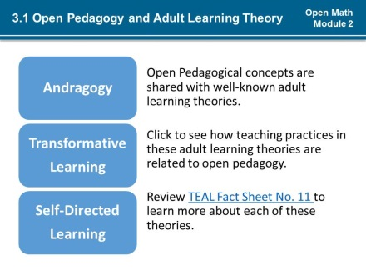  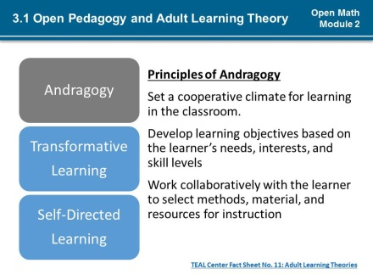  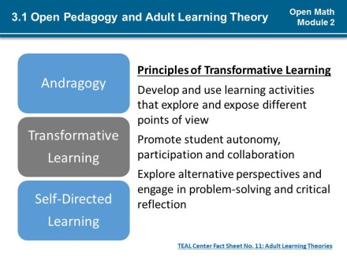  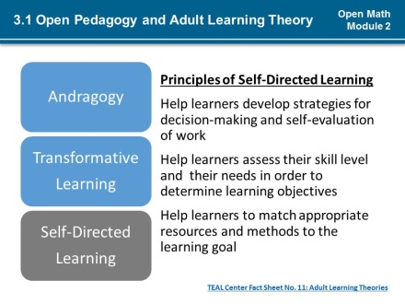
3.2 | (*1) In addition to the prevailing theories about how adults learn, performance standards and teacher and student practices also influence approaches to instruction and learning.  (*2) These guidelines such as the College and Career Readiness Math Standards for Adult Education; 21st Century Skills, and the National Council of Teachers of Mathematics Teacher Practices are intended to help all learners succeed and be prepared for assessments, success in the workplace, and further education.  (*3) Many of these guidelines promote learning experiences that develop knowledge and skills through the active involvement of students. You might use these and other frameworks for instruction to guide how you use Open Educational Resources with open pedagogical practices to open your classroom. | Fade in paragraph that begins “performance standards” (*1)  Fade in paragraph that begins “these guidelines” (*2)  Fade in paragraph that begins “ many of these” (*3) | 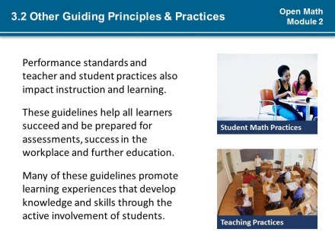
3.3 | Click to learn more about math practices for students and practices for math instruction. | Student practices links to 3.4  Teacher practices links to 3.5 | 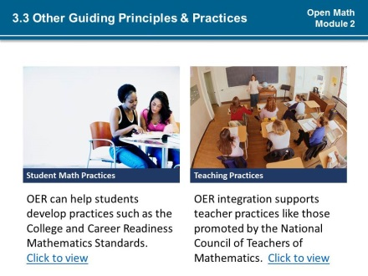
3.4 | None | None | 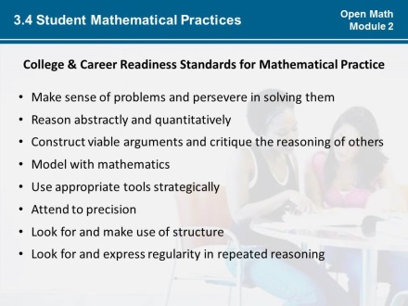
3.5 | None | None | 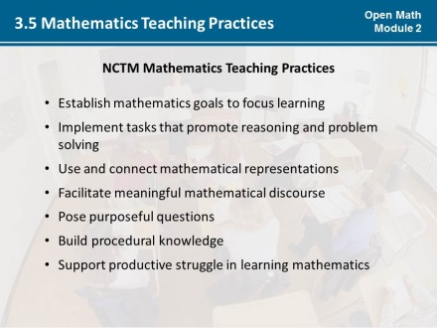
3.6 | No matter how they arrive at their learning objectives, in an open classroom teachers and learners are taking full advantage of the permissions associated with Open Educational Resources while developing critical skills and practices – such as those found in the College and Career Readiness Standards and the others you just reviewed. In addition to teacher use and creation of OER for instruction, students are creating, adapting and sharing open resources to accomplish learning objectives. Take a moment to think about the various practices, theories, guidelines that shape how you teach. When you are ready, click next to answer the question “How open is your classroom?” | none | 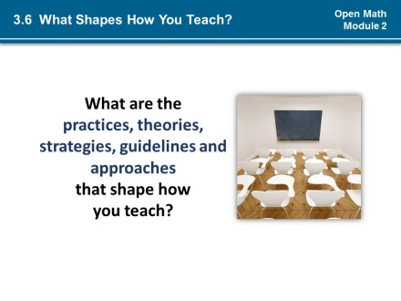
4.0 | None | This is a quiz with a text introduction.  Format as needed. All questions do not need to appear on a single slide.  Scoring notes: | 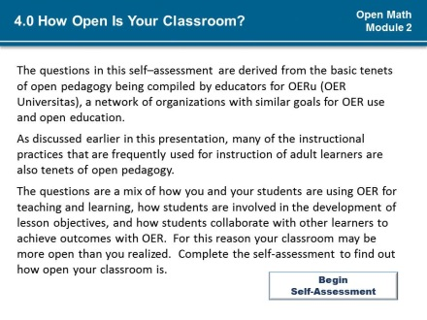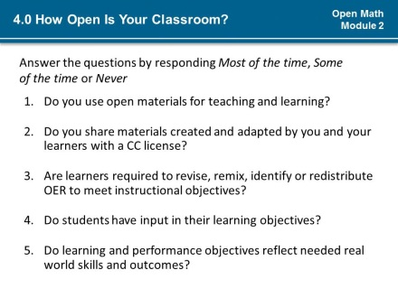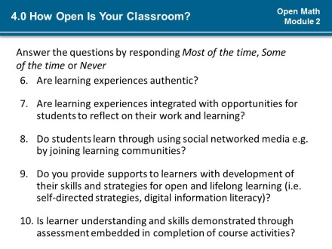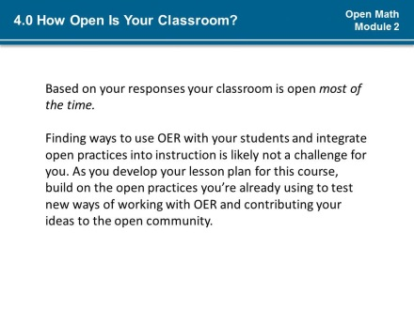
5.0 | Note that while you may be doing many wonderful things with learners and engaging them in many of the ways associated with open pedagogy, if you are not having them use Open Educational Resources then what you are doing is not truly open pedagogy. (*1)  Using OER is an essential piece of opening your classroom because open pedagogy is premised on leveraging the permissions associated with OER. The strategies for using OER to make your classroom open are easily remembered because they involve the permissions associated with OER. Open pedagogical practices for teaching and learning require learners independently or in groups to revise; remix; redistribute or create OER. | Pulse exclamation points (*1) | 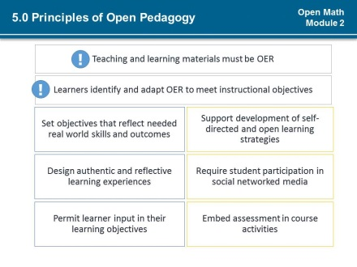
5.1 | Review the principles of open pedagogy before moving on. | none | 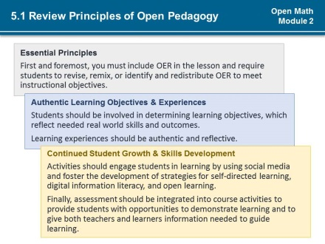
5.2 | In addition to the open pedagogical practices that require student use of Open Educational Resources, educators must create conditions in the classroom that support student use of an OER. To do this, teachers create a safe space for learners to share their goals, experiences, and engage with the instructor and other learners; provide a basis for student self-assessment of their work; and provide formative feedback to learners. | none | 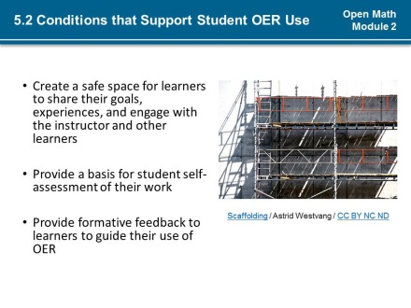
6.0 | Review this description of a math lesson. As you read determine what open pedagogical practices were used. | none | 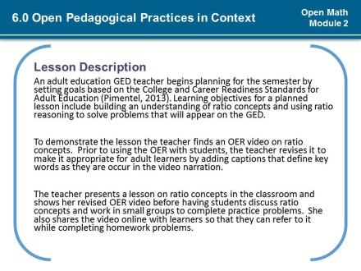
6.1 | The teacher in this example utilized OER, but did not involve students in revising or remixing OER. How can the teacher transform this into a more open lesson? | none | 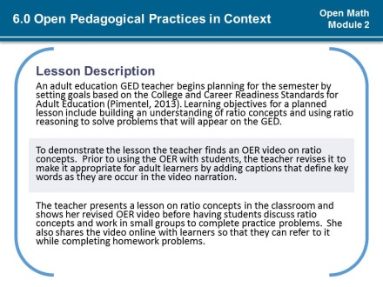
6.2 | In the original lesson the teacher revised a video on the lesson topic and showed it to students. Then, the teacher had students practice together in groups to apply the concepts presented in the video. The teacher provided students with access to the video to support independent practice.  Here are just a few ways the teacher could have used open pedagogical practices to open the lesson:  (*1) After the lesson was introduced, assign students to organize and transform the OER used to develop a more effective lesson.  (*2) The teacher could have assigned students to remix the video with other OER video.  (*3) Students work in small groups, pairs, or individually to identify other OER on the topic.  (*4) After final feedback from the teacher, students might engage in peer teaching with the new materials they created.  All students should be encouraged to upload all final remixed lessons to an online repository, identifying it as adult education resources, so that other adult education learners and instructors can identify and use the materials.  A teacher could use just one or a combination of these strategies to open the lesson. Note that the key difference in the lesson with these strategies is that students are able to take advantage of the permissions of the OER to meet the goals for the lesson. In doing so, the students will need to first assess what they need to know, and collaborate with the instructor and their peers to accomplish the lesson objectives. | Transition to next slide (*1-4) | 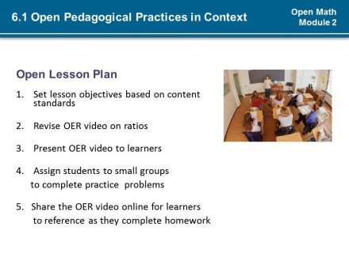  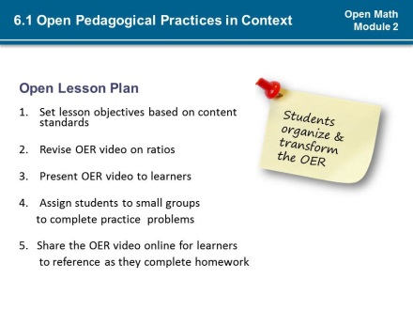  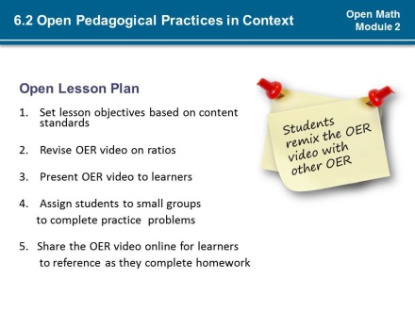  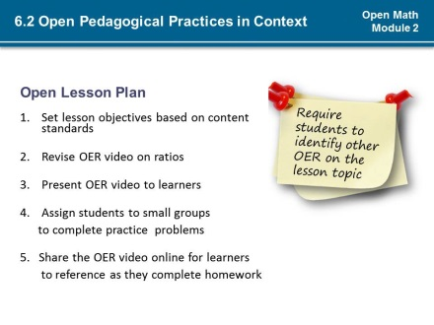  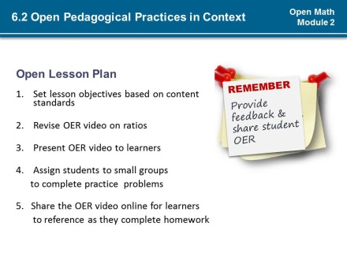
7.0 | The qualities of Open Educational Resources afford unique opportunities to enhance and extend instruction and learning by allowing for more collaborative, student-directed, and personalized teaching and learning.  (*1) These resources can be used in many of the same ways as other resources, but without barriers to access due to cost or copyright restrictions, with an added benefit of providing students with control over content and opportunities to share resources and knowledge.  (*2) Open pedagogical strategies for teaching with OER, along with other adult education strategies and sound lesson planning, involve students in the shaping of instructional content and resources in ways that help to reflect and enrich their learning. | Transition to next slide (*1-2) | 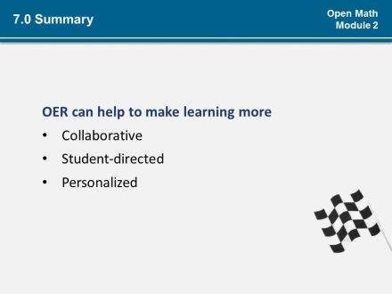  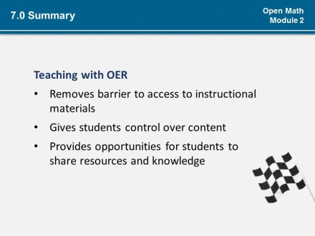  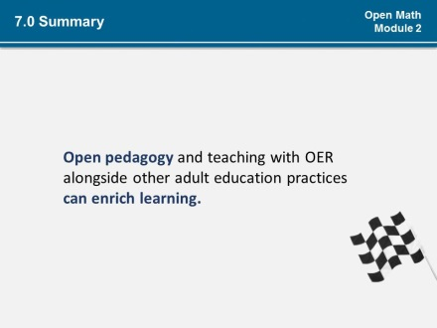
7.1 | (*1) Consider these questions as you work through the activities for this module:  (*2) What is your vision for an open math class?  <<Pause>>  (*3) What practices will guide your vision of open instruction?  <<Pause>>  (*4) What does open pedagogy mean to you?  <<Pause>>  (*5) What practices will you help students to develop in your open math class? | Float in question mark (*1)  Fly in questions (*2-5) | 