Course 1, Module 3
Mike: Can we chat about the embedded videos in this module. I’m using videos from OER Commons and they are not Creative Commons licensed, so I can’t revise them to clean up the (horrible) captioning. Can we provide captioning within Storyline, even if we are grabbing a video off of YouTube? Does taking an embed code automatically include the captions if they are enabled?
Also, I grabbed some images as screenshots last night – they are NOT in the shared drive; do I need to go and re-grab them?
Open Your Classroom to Open Educational Resources (Banner Title)
Module 3 – Searching for OER and Exploring OER Repositories
Screen Number | Screen Title
1 | How do I find OER using Google?
Lecture/Narrative |  | Visuals
Now that you have a solid understanding of Open Educational Resources (OER) and Creative Commons (CC) licensing, let’s spend some time learning ways we can find these resources using the popular search websites Google and YouTube.  On the next page is a screencast tutorial that will guide you through the following process:  - Define your search query—What is the question?  - Identify key terms.  - Write effective search terms to find what you want and refine your search.  - Use advanced search features to improve your search results further.  Suggested Activity: As you experiment with these new tools for searching, use the Search Worksheet (link to file) to keep notes on the queries you try, the results you get, and what websites you were referred to. This information will be useful to help you refine your search strategies further. |  |     Earth and Magnify glass by Kuba is free of known copyright restrictions
Audio
Notes
Mike: Link to file: “Searching Worksheet.odt” Here: W:\STEM-OER\C1M3-Assets\C1M3-Docs-handouts
Link to image title: http://openclipart.org/detail/169660/earth-and-magnify-glass.-by-kuba
Link to user/creator: http://openclipart.org/user-detail/kuba

Screen Number | Screen Title
2 | Searching for OER using Google and YouTube
Lecture/Narrative |  | Visuals
{Embedded screencast as described in previous screen}  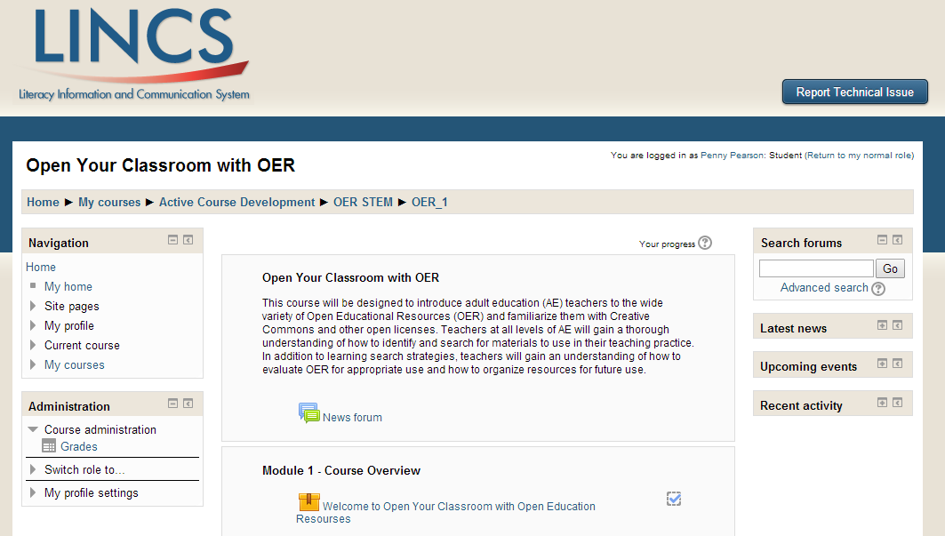 |  | Video player slide with placeholder for now  Mike: Screenshot can be used as placeholder; it is NOT in the shared drive.
Audio
Script TBD – based off of UG webinar on searching for OER, need to be at 5 minutes The screen cast will prompt users to pause the video and practice, and to keep notes on their results.
Notes
Mike – working on this script!

Screen Number | Screen Title
3 | OER Repositories
Lecture/Narrative |  | Visuals
As you experiment and explore searching for OER, you will likely find that many resources are found on a few common websites. These sites are called repositories and they work as a collection system: They find different resources and classify, organize, and tag them by a variety of means. They can be classified by type (document, game, simulation, video lecture, textbook, full courses, images, audio files, and more), subject area (math, science, social studies), level (primary, secondary, postsecondary), and conditions of use. The conditions of use will tell you how you can use material in a collection according to the license its creator has chosen.  Many repository websites curate OER materials. OER Commons is a repository particularly useful to adult educators because it has added adult education (AE) to its “grade level” filter. This has a twofold effect:  - You can search for materials reviewed and identified as appropriate for adult learners, and  - You can review and evaluate other OER and tag (mark) them as appropriate for adult learners.  Searching for resources on a repository site is a little different from using Google. The next page links to a short tutorial from OER Commons on how to search that site.  Note: The focus for this activity is OER Commons, but you are encouraged to explore other repository sites (see the resources section for some suggestions). |  | OER Commons logo  
Audio
Notes
Mike; link the logo to: http://www.oercommons.org,
Attribution is not needed.

Screen Number | Screen Title
4 | Searching OER Commons – a Repository Site
Lecture/Narrative |  | Visuals
{Embedded screencast as described in previous screen}  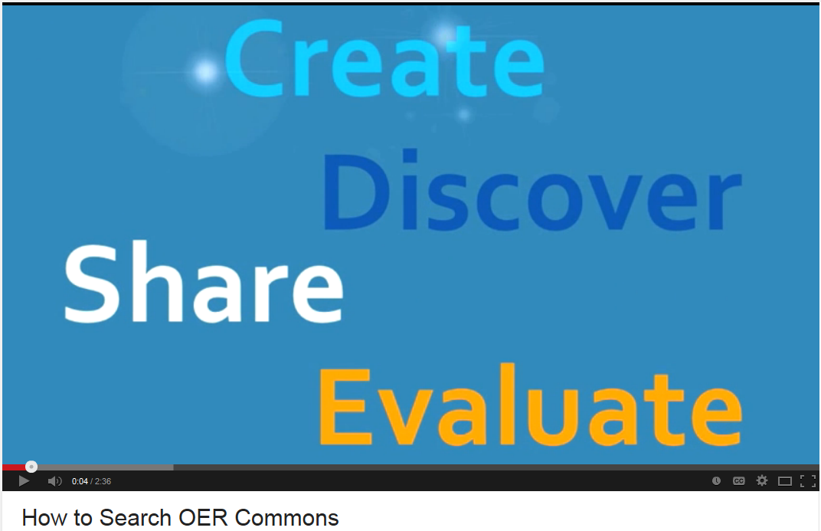  Suggested Activity: Using your notes, see whether you can find AE resources on the OER Commons site. You may see some duplication from earlier searches, or you may see new and exciting resources that you can use! |  | Video player  Needs to display captioning too.  Mike: Screenshot can be used as placeholder; it is NOT in the shared drive.
Audio
Notes
Mike: This video needs to be embedded. Be sure the closed caption option is available and the embed code “show suggested videos when the video finishes” is UNchecked so viewers are not presented with a bunch of additional ‘suggested videos.’
Source: https://www.youtube.com/watch?v=JXFUOVxv0gY 2:36 minutes Standard YouTube license

Screen Number | Screen Title
5 | Reviewing OER and Using Groups in OER Commons
Lecture/Narrative |  | Visuals
Because OER Commons is mindful of the needs of adult educators and learners, it is a good place to submit your own CC licensed materials and review/evaluate other resources, too. This will help build many resources for everyone to use. It is important that, as adult educators, that you can find appropriate, valuable, educational materials to support your learners. Through OER Commons, you can not only be a creator/contributor, you can also review materials created by others and deem them appropriate for adult learners.  The next few pages provide tutorials on creating an account at OER Commons, using groups, and aligning and evaluating a resource on OER Commons.  Suggested Activity: Read the “About” page at OER Commons [Link to PDF] |  | Add Lucy for graphic interest.
Audio
Notes
Mike: The “about” PDF is in the ‘C1M3 Docs-handouts’ folder on the shared drive, named “About OER Commons.pdf”. Do you know of a way I can check that PDF document for accessibility?

Screen Number | Screen Title
6 | Creating an Account on OER Commons
Lecture/Narrative |  | Visuals
Embed video from: https://www.youtube.com/watch?v=7VuzLuPXMzo  How to Create a Profile on OER Commons (2:06)  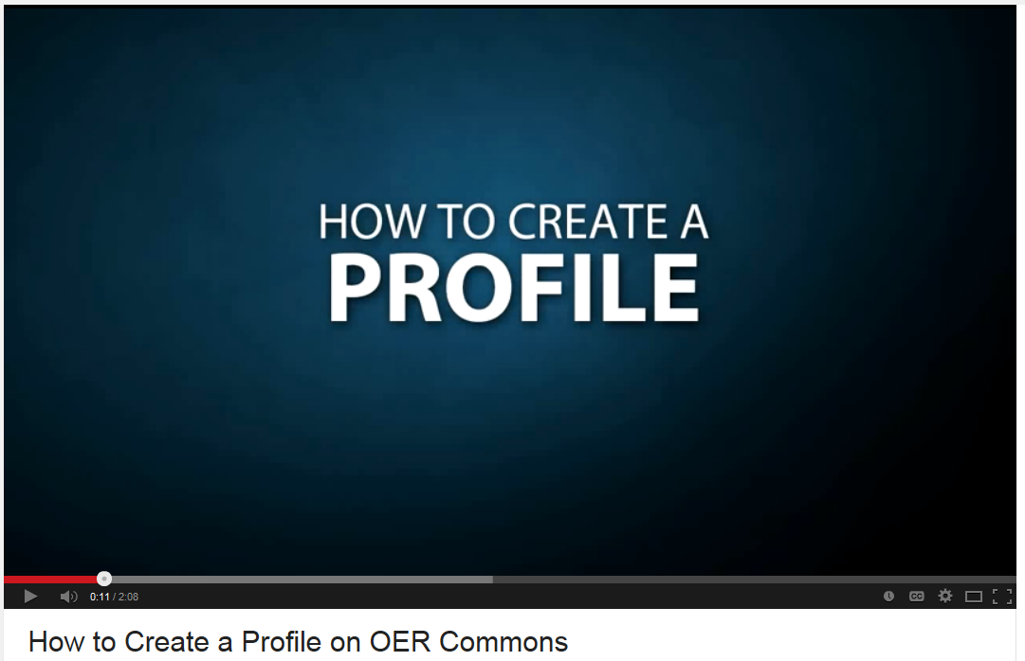  Suggested Activity: Create an OER Commons account. |  | Video player  Needs to display captioning too.  Mike: Screenshot can be used as placeholder; it is NOT in the shared drive.
Audio
Notes
Mike: This video needs to be embedded. Be sure the closed caption option is available and the embed code “show suggested videos when the video finishes” is UNchecked so viewers are not presented with a bunch of additional ‘suggested videos.’

Screen Number | Screen Title
7 | How to Use Groups on OER Commons
Lecture/Narrative |  | Visuals
The OER STEM project [link to project page] introduced adult educators from around the United States to the process of reviewing and evaluating OER for use in the AE classroom. You can find this group, “Adult Education Open Community of Resources,” in OER Commons. You are encouraged to join the group to share AE-specific resources with other adult educators using OER in their teaching.  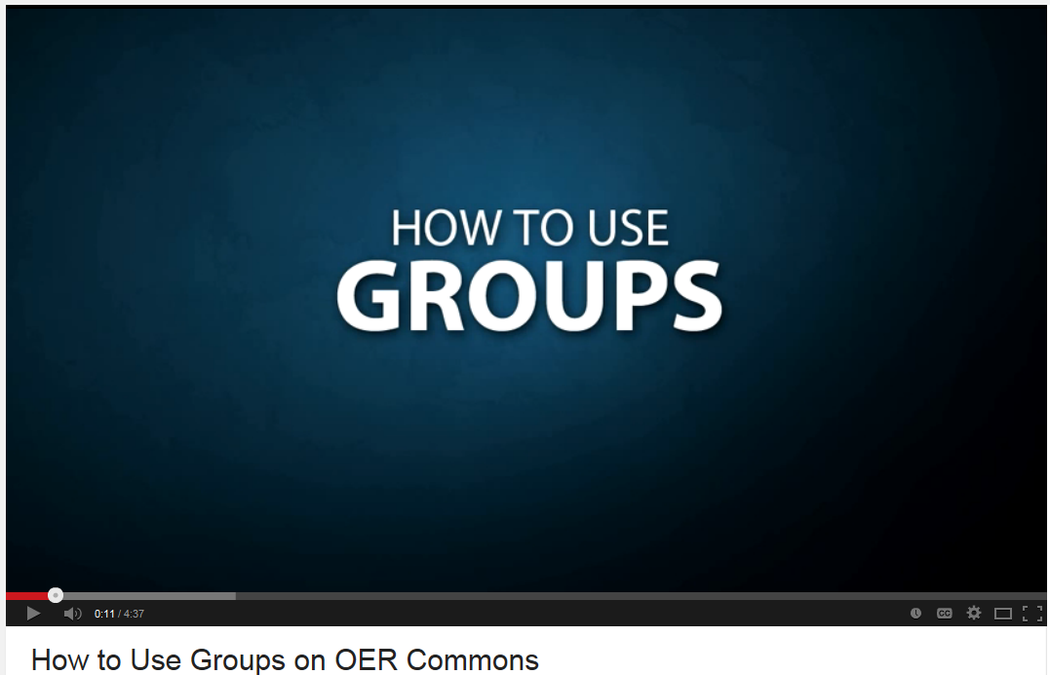  Embed video from: https://www.youtube.com/watch?v=VRQs6HRmsvc  How to Use Groups on OER Commons (4:13) Standard YouTube license  Suggested Activity: Create an account on OER Commons and join the Adult Education Open Community of Resources group, or any other groups that interest you. |  | Video player  Mike: Screenshot can be used as placeholder; it is NOT in the shared drive.
Audio
Notes
Mike; the videos from the OER Commons site will have to be embedded (They are not CC licensed so we cannot download them and put them up in our own YouTube channel). Please be sure to get the embed code “show suggested videos when the video finishes” is UNchecked so viewers are not presented with a bunch of additional ‘suggested videos.’ I want to make sure that the “closed caption” button is available within the presentation. I found you can turn them on automatically, but it doesn’t say if the user can turn them OFF. From YouTube ‘embedding options’ Make captions automatically appear for an embedded video by adding "&cc_load_policy=1" to the video's embed code. (from: https://support.google.com/youtube/answer/171780?expand=PrivacyEnhancedMode#privacy)

Screen Number | Screen Title
8 | How to Align & Evaluate a Resource on OER Commons
Lecture/Narrative |  | Visuals
Embed video from: https://www.youtube.com/watch?v=l-7QqHZqaEs  How to Align & Evaluate a Resource on OER Commons (5:35)  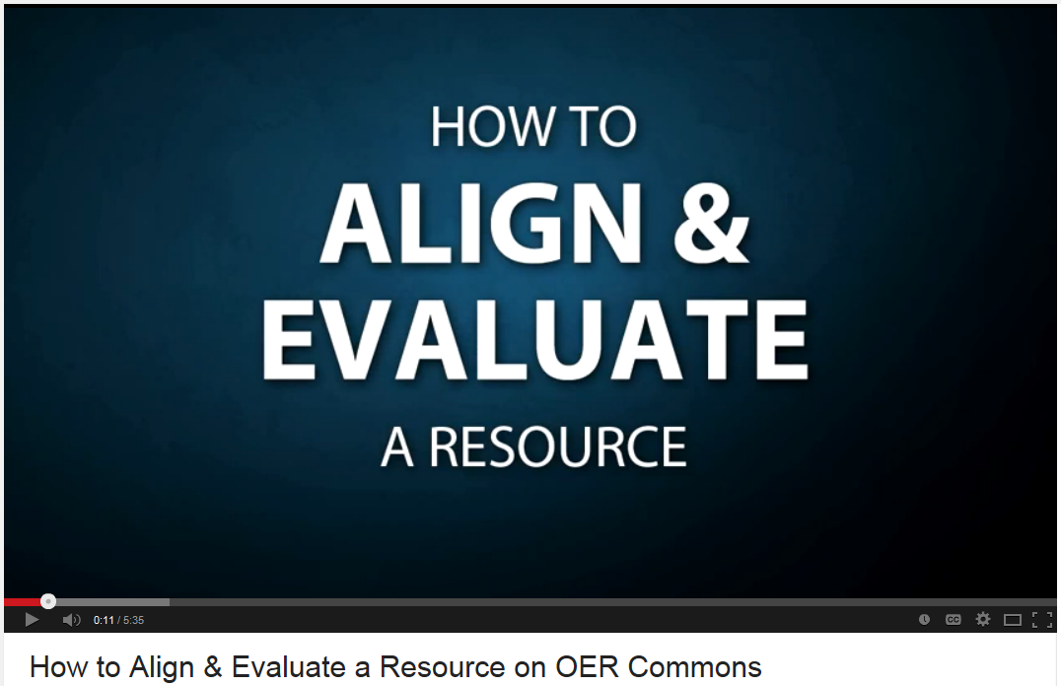  Suggested Activity: Select an OER you found through your search of OER Commons. Evaluate that resource and be sure to submit your evaluation so others can benefit. Don’t forget to tag the resource “adult education,” if appropriate, as explained in the tutorial video from OER Commons. Be sure to return to this module to review the video as needed. There are also great “Help” resources on the OER Commons website. |  | Video player with the suggested activity text underneath it.  Mike: Screenshot can be used as placeholder; it is NOT in the shared drive.
Audio
Notes
Mike: Please be sure to get the embed code “show suggested videos when the video finishes” is UNchecked so viewers are not presented with a bunch of additional ‘suggested videos.’

Screen Number | Screen Title
9 | Your OER Portfolio on OER Commons
Lecture/Narrative |  | Visuals
When you create an account on OER Commons, your portfolio and profile are automatically generated. The portfolio allows you to save your searches, individual OER, tags, ratings, reviews, comments on resources, and your own submitted materials—all on OER Commons. You can get to all these items quickly by clicking on the “My OER” link at the top of the page.  Suggested Activity: Review other tutorials on OER Commons. On the OER Commons home page, select “OER Wiki” at the bottom and then “OER Tutorial” from the navigation panel on the left. |  | Add Lucy here.
Audio
Notes

Screen Number | Screen Title
10 | Reflection Activity
Lecture/Narrative |  | Visuals
You spent a lot of time learning about effective searching using key terms, query operators, and other filtering tools to find OER and CC licensed materials. In addition, you spent some time looking at OER Commons, an OER repository. That’s quite a bit of information!  To help assimilate and organize this information, please spend a few moments to consider what you have learned. How could this information influence your teaching? Has it changed the way you find materials? Could it change how you create (and hopefully license) your own materials?  Please write a short paragraph to post to the LINCS Community [Link to groups page https://community.lincs.ed.gov/groups] of your choice. Be sure to introduce your post as an activity from the “Open Your Classroom With Open Educational Resources” course on the LINCS Learning Portal. |  | Thoughtful person, pen in hand, or in front of a computer…Sample:    By Petr Kratochvil Wikimedia Commons
Audio
Notes
Mike, two copies of the image are in the shared drive. License info is the same for both images.

Provide link to LINCS home page https://community.lincs.ed.gov/groups

Screen Number | Screen Title
11 | Next Steps
Lecture/Narrative |  | Visuals
You have reached the end of this module and the end of the course content. Congratulations!  There’s one last item for you to complete before you close out this presentation and return to the main course page. See the next page, “Last Tasks,” before you go!  Then be sure to check off on the course home page that you have completed this module!    Suggested Activity: Retake the “OER Knowledge Check” quiz and watch your scores improve! |  |   Flickr One Way Stock
Audio
Attribution text: Work found at https://www.flickr.com/photos/paulbrigham/9002177586 / undefined (https://creativecommons.org/licenses/by-nd/2.0/)
Notes
Mike, this image may be too small. Let me know, I’ll hunt up another.

Screen Number | Screen Title
12 | Last Task!
Lecture/Narrative |  | Visuals
The last item you need to complete is Module 4, the Course Evaluation. Please be sure to fill it out. Your feedback is important and it will help provide needed information to make improvements to this course.  After you complete the evaluation, you will be eligible for a course completion certificate. Be sure to save a copy because it will provide documentation that you have met the prerequisites for the next courses, including:  Open Math—Open Resources: Engage Adult Learners for 21st-Century Skills and  Open Science—Open Resources: Engage Adult Learners for 21st-Century Skills  These are facilitated courses and will have different start dates. Check with your nearest LINCS Regional Professional Development Center [link to site: http://lincs.ed.gov/lincs/regionalresources/regional_centers.html]to learn about the next offering of these courses. |  | Happy person holding a certificate or award.
Audio
Notes

