Mike: From what I’m reading (it’s just a little! http://scorm.com/scorm-explained/technical-scorm/) SCORM allows us to “package” all of our assets into one box. It looks like it works (I did a little demo) for files (.pdf .doc) but not for video. The referenced videos to YouTube will have to be either downloaded and transcripts/caption files made OR AIR will give me credentials where I can copy the files, clean up the captions and then we can use the embed code. We are trying to avoid links that will break in the future.
Open Your Classroom to Open Educational Resources (Banner Title)
Module 2 - Defining “Open” and Understanding Licensing Options (Banner SubTitle)
Screen Number | Screen Title
1 | The Wonderful World of OER!
Lecture/Narrative |  | Visuals
As an educator, you are amazing: you dedicate time, effort, and personal resources to find the best ways to reach learners. You create presentations, handouts, check sheets, and other resources to help your learners with all aspects of their studies. You often share what you create with your colleagues, especially when a lesson goes exceptionally well for both you and your learners.  Although you may not have the time or expertise to create fancy or complex learning objects like games or interactive programs that help students learn, you do know there are many excellent resources on the Web that could benefit your learners. Wouldn’t it be great if you could use lesson plans, websites, videos, documents, interactive games, and more in your classroom and know you are respecting copyright laws and maybe even offering your skills and knowledge to others?  One solution that allows you to use materials freely—and remix and revise them—is open educational resources (OER)! OER materials can be used in your teaching practice and for your own professional development.  These items could be simple documents—a textbook, a presentation, video lectures, screencasts, or any number of resources you can find online. The fact that they are open means that you can also revise or remix these resources for your classroom.  So, what are OER? Click the “next” button below to start learning about them! |  | Something bright; utopia, elicit happiness  Happy teacher?
Audio
Notes
Mike: Images need to be credited, Flickr has a really nice tool that allows you to place the credit right underneath the image (see slide image on screen 9) Do you have a tool like that? Or do we do it all via your magic programming? I have a great “attribution guidelines” document if you want it.

Screen Number | Screen Title
2 | Open Educational Resources (OER)
Lecture/Narrative |  | Visuals
Although there are numerous working definitions of open educational resources (OER), this is the definition in the National Educational Technology Plan: “Open Educational Resources (OER) are teaching, learning, and research resources that reside in the public domain or have been released under an intellectual property license that permits sharing, accessing, repurposing—including for commercial purposes—and collaborating with others.” (Emphasis added.)  {Box as a video placeholder.} |  | Text based slide with OER logo {or combined graphic    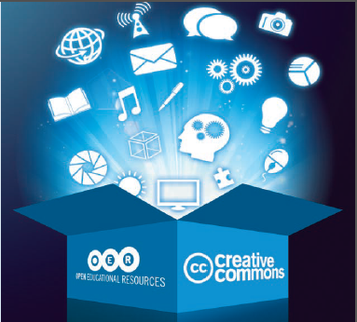  This is OTAN created graphic for our newsletter – will get it CC licensed. Or can use images that represent different types of OER (files, books, podcasts, movies, lesson plans, websites, music, game images etc.)
Audio
Notes
Mike: The referenced video is not useable in its current state. I have uploaded it to my YouTube Channel and am cleaning up the closed captions. Can we put a placeholder graphic for now?

First Image Source: http://en.wikipedia.org/wiki/Open_educational_resources (logo files are here as well) Licensed: CC BY SA

Original text from the Narrative section above, for Penny’s info
{Placeholder for an appropriate promotional video about the value/virtue of OER. Can use some of the winning videos from the Why Open Matters contest, or find something more conducive to Adult Education}
Suggestion: “The OERs—Open Educational Resources” by intheacademia on YouTube; https://www.youtube.com/watch?v=-xGRztrWv-k
CC licensed, remixable. Closed captioning needs to be cleaned up.
Provide links in the slide or on the resource page?
Definitions page: http://wiki.creativecommons.org/What_is_OER%3F

Screen Number | Screen Title
3 | OER and the 5Rs Framework
Lecture/Narrative |  | Visuals
The key to understanding OER lies in the phrase “resources that reside in the public domain or have been released under an intellectual property license that permits their free use and re-purposing by others.” David Wiley at Open Content refined this concept through the “5Rs Framework:”  “The primary permissions or usage rights that open content is concerned with are expressed in the 5Rs Framework as follows:  - Retain—the right to make, own, and control copies of the content (e.g., download, duplicate, store, and manage)  - Reuse—the right to use the content in a wide range of ways (e.g., in a class, in a study group, on a website, in a video)  - Revise—the right to adapt, adjust, modify, or alter the content itself (e.g., translate the content into another language)  - Remix—the right to combine the original or revised content with other open content to create something new (e.g., incorporate the content into a mash-up)  - Redistribute—the right to share copies of the original content, your revisions, or your remixes with others (e.g., give a copy of the content to a friend)  Content is open to the extent that its license allows users to engage in the 5R activities. Content is less open to the extent that its license places restrictions (e.g., forbidding derivatives or prohibiting commercial use) or requirements (e.g., mandating that derivatives adopt a certain license or demanding attribution to the original author) on a user's ability to engage in the 5R activities.” This material was created by David Wiley and published freely under a Creative Commons Attribution license at: http://opencontent.org/definition/.  Suggested Reading: The 7 Things You Should Know about OER (PDF)  Suggested Videos: There are many videos on the use of OER on YouTube. Search for “what are open educational resources.” Try the filtering options (at the top of the search results) to refine your results. |  | Text slide; Add Lucy to the page
Audio
Notes
Mike:
Link to the “7 things” PDF as a course resource; I will put the PDF in our shared drive. “EduCause-Things you should know.pdf”

Screen Number | Screen Title
4 | Match Me Up!
Lecture/Narrative |  | Visuals
Match the phrase to the correct definition. Drag the item from one place to the other.

Matching items to be developed:

Definition of OER—text box with definition
OER Values—as discussed in values video
Types of OER—graphic image (could reuse the one on slide 2) representing files, music, images, audio, textbooks, etc.
The 5R’s Framework—retain, reuse, revise, remix, or redistribute
Audio
Notes
Mike: Not sure what would be the best format for this; FAQ interaction slide, or the Sticky Notes. If we use FAQ we’ll have to change the items to questions.

Definition of OER = “Open Educational Resources (OER) are teaching, learning, and research resources that reside in the public domain or have been released under an intellectual property license that permits sharing, accessing, repurposing—including for commercial purposes—and collaborating with others.”
Types of OER = (Could use image?) Text files, lesson plans, video lectures, video presentations, presentation files, music, images, textbooks, most anything that can be found on the Internet.
The 5R’s Framework = Retain, reuse, remix, revise and redistribute.
Value of OER = (from the OER Video) Openly shared materials for everyone, access for free, tailor learning for all, equal access to knowledge

Screen Number | Screen Title
4A | Open Pedagogy
Lecture/Narrative |  | Visuals
The 5Rs of OER are foundational to the concept of open pedagogy, a practice of openness in learning and teaching that shares all phases and elements of instruction. In David Wiley’s TEDxNYED presentation he states, “Education is inherently an enterprise of openness and sharing and generosity.” Teachers share information with learners, and they share resources with other educators. As we move forward and embrace OER and more openness in education, we can encourage a practice where learners create, innovate, reflect, connect, and share their experiences with other learners and teachers.  This is all possible because of advances in technology, specifically the sharing of information and resources through the Internet. There are now unique opportunities to enhance learning by allowing for more collaborative and personalized learning for both learners and teachers.  Bronwyn Hegarty created a model of open pedagogy based on the work of Conole (2013), Designing for Learning in an Open World, which models eight interconnected attributes as the foundation for open education practice. These attributes include technology, innovation and creativity, the sharing of ideas and practice, connected community, reflective practice, and more. With OER and the application of David Wiley’s 5Rs, it is possible to envision how open pedagogy can transform teaching and learning.  Suggested Activity: Use Google Scholar to search for articles on “open pedagogy.” As you review a few articles, consider how this practice may influence your teaching. How do you think the use of OER and the idea of open pedagogy could transform adult education (AE)? |  | Use Lucy for now, AIR said they would find or develop an appropriate model graphic.
Audio
Notes

Screen Number | Screen Title
5 | Free vs. Open
Lecture/Narrative |  | Visuals
In our digital climate today, it is easy to find interesting and exciting resources online to help teach a particular topic. However, not all resources that you can find on the Internet are available for use. Many resources that you find online are protected by copyright licenses.  That is why OER are important and valuable resources for the AE teacher and learner. By searching for openly licensed materials, you can be confident that you are using the materials as intended by the author. With some strategic searching (more on that later) and a diligent review of the materials offered, you can find materials clearly licensed for you to use in almost any way you choose. The most common open licensing options used today can be found at Creative Commons (CC) a non-profit organization that provides licensing options. You will learn more about those licenses in the next section.  As an educator, you should always check the license on any materials you want to use. Assume that a resource is protected by copyright unless the site specifically states otherwise. You can look under “Terms of Use,” “Copyright,” or “Terms of Service” on the website to determine the usage rights of a resource. This information is usually displayed in links at the very bottom of the Web page in small print. What if you have looked but are still not sure whether a resource is copyrighted? Ask. Most websites offer a “Contact Us” or “Help” link. |  | Text with a learning coach image.  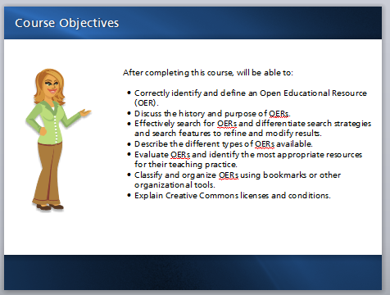
Audio
Notes

Screen Number | Screen Title
6 | Creative Commons Licensing
Lecture/Narrative |  | Visuals
The best introduction to CC is through its own materials. Watch the  3-minute video Wanna Work Together? shown below.  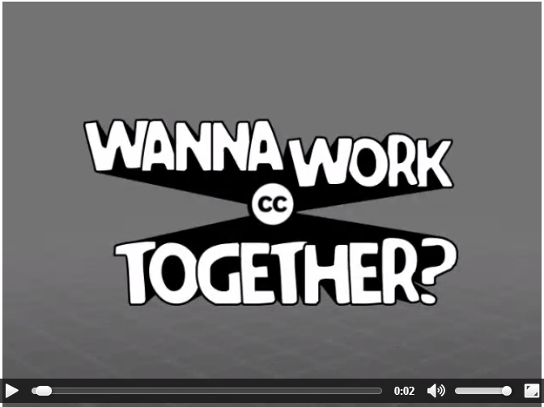  Time: 3:00 minutes |  | Creative Commons Logo; selected open license logos (CC0; CC BY, and CC BY SA)  
Audio
Notes
Mike: The video will have to be downloaded and captions added. I was able to get an .ovg file but not sure if that will work in storyline.

Video resources: http://creativecommons.org/videos
Wanna work together video download 55 MB, CC BY license; http://mirrors.creativecommons.org/wwt-sources/wannaworktogether_dv.mov (3:00 minutes)
Transcript: http://wiki.creativecommons.org/Videos/Wanna_Work_Together/transcript

Screen Number | Screen Title
7 | Intellectual Property and Creative Commons Licensing
Lecture/Narrative |  | Visuals
  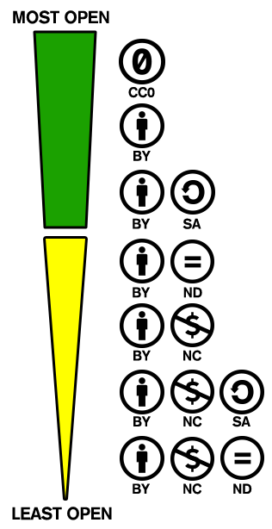  As a creator, you can license your work in a way that states your permissions for use to any other user. As previously mentioned, the most common open licenses are CC licenses. (Creative Commons is not the only provider of open licenses.) Licenses vary from the most open, with no restrictions, to the least open, with specific restrictions such as no derivative work (you cannot adapt it) or no commercial use (you cannot sell it). This does not mean that these more restrictive materials cannot be used; it only means that you must be aware of how such works can be used. |  | “Free” graphic  Creative Commons logo  “Most Open/Least open” and the License Mixing Graphic
Audio
Notes
Mike: I want to include the graphic for “free cultural works” aligned with the “green part” of the graphic on the left (these 3 licenses are considered ‘free cultural works’ )

________________
Links for Resource page:
http://www.copyright.gov/
http://www.copyright.gov/circs/circ01.pdf (could be a resource document)
http://en.wikipedia.org/wiki/Copyright
http://creativecommons.org/
Examples of Creative Commons License Use:
http://creativecommons.org/examples
Center for Educational Research and Innovation “Giving Knowledge for Free”
http://www.oecd.org/edu/ceri/38654317.pdf (C) 2007, no reproduction, copy transmission or translation of the work without prior written permission.

Screen Number | Screen Title
8 | The 6 Creative Commons Licenses
Lecture/Narrative |  | Visuals
CC uses six main licenses (not counting public domain) to mark work. The following images and text show the CC icon used on licensed work and explain what each license allows a user to do.  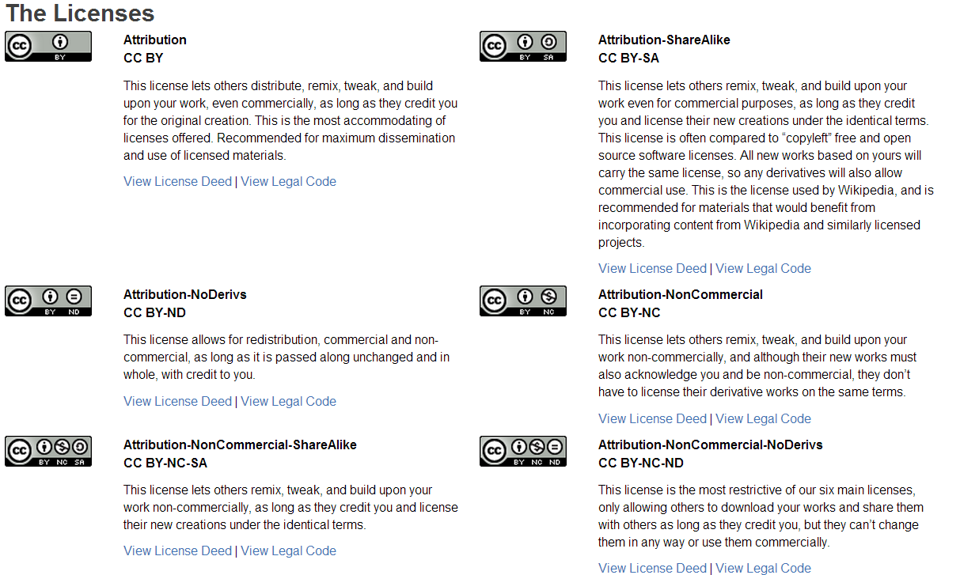  Suggested Activity: If you would like to try your hand at understanding how to remix several CC licenses together, try the “License Compatibility Game” on the WikiEducator.org site. |  | CC License logos with descriptive text  Be sure to ADD the FREE CULTURAL WORKS icon with appropriate licenses as well. (CC0, CC-BY and CC BY-SA)
Audio
Notes
Mike: I have the graphics saved from screenshots and put them in our drive: W:\STEM-OER\C1M2 Files resources. Lets talk about how we can convey this information. AIR wants this in a text format as well as a “job aid” (handout) I think I can pull that together quickly and we can provide a link to a PDF from within this slide. The icon image needs to be separate from the descriptive text. Duplicate the images and text from Creative Commons: http://creativecommons.org/licenses/
Need to include public domain: http://creativecommons.org/about/cc0
Need to include “free cultural works” image and definition too: http://creativecommons.org/freeworks

Developer notes:
Suggest this used as a “sticky note” page. Image on the note, license description as the text.

Screen Number | Screen Title
9 | Match Me Up!
Lecture/Narrative |  | Visuals
Match the phrase to the correct definition. Drag the item from one place to the other.  Matching items to be developed:  Free Cultural Work —text box with definition  Open licensing—text box with definition  Copyright license—text box with definition  CC BY—text box with definition  OER Values—as discussed in values video |  | To be determined
Audio
Notes
Mike: this would need to be in an alternate format for accessibility – not sure what, if any, graphics would stand alone. Maybe graphics with the desriptions/definitions?

Free Cultural Work = Works that can be most readily used, shared, and remixed by others, and go furthest toward creating a commons of freely reusable materials.
Open Licenses = Specific license permissions allowing creators to specify how their works may be used.
Copyright = United States government license given creators of original works protecting those works from unauthorized use such as copying.
CC BY = An example of a Creative Commons Attribution license designation. (Include graphic with this answer)
OER Values = OER are shared materials for everyone. They can be accessed for free or low cost on the Internet. They provide the ability for anyone to tailor learning for all, and give equal access to knowledge.*

Screen Number | Screen Title
9 | Licensing Your Own Work
Lecture/Narrative |  | Visuals
As an educator, you are a creator. Your lesson plans, handouts, presentations, screencasts, videos, podcasts—all those things you create to help your learners—are products of your expertise. As a creator, you can license your work and share it with others. When you do so, you are creating an OER and you are contributing to a worldwide knowledge base of instructional materials openly available to learners and educators.  Why should you license your work? Listen to Justin Cone, the creator of Building on the Past and winner of the Creative Commons Moving Images Contest.  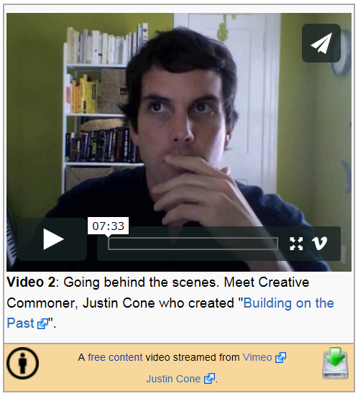  Time: 7:03 minutes  If you would like to watch his award-winning video, you can do so through this link. [opens a second layer with the video embedded] |  | Text with the embedded video of Justin Cone
Audio
Notes to Developer
Mike: Another video dilemma – I have this video, Holly is transcribing so we can set up the captions. It is also in our shared files (C1M2) However, OCTAE is wanting something more in line with an adult educator creating OER, so this may change!
__________________________________
OCTAE: It is preferable to use an adult educator who would proclaim the positive power of using OER in their classroom. This is just a placeholder to either find such a video, or produce our own.

Download and embed video from Justin Cone (http://wikieducator.org/Creative_Commons_unplugged) Free Content, MP4 format, 42.3 MB
“Building on the Past” should be available on a second layer, only playing when selected by the user.

Screen Number | Screen Title
10 | Considerations for Licensing
Lecture/Narrative |  | Visuals
You may not think licensing your materials is worthwhile. However, if at any time a colleague has asked for a copy of something you have done, you deserve to:  1) license it so you receive credit for the excellent work you produce;  2) ensure the material is used in a way you deem most appropriate; and  3) be recognized as a contributor to educators everywhere far beyond your local classroom.  In the later modules of the course, you will learn about places where you can potentially share your work. This sharing process can be as simple as your own class website, your school’s Web page or local file servers, or Web-based OER repositories where people from all over the world share their work with educators, researchers, and lifelong learners.  Suggested Activity: Read “Considerations for Licensors” on the CC website. Use these guidelines to think about how you would want your work licensed. (You will learn more about places where you can share your licensed materials in a subsequent module.)  Next, try the CC license chooser. This simple tool allows you to select different characteristics of how you want your work to be used and provides license text, a graphic, and an embedded code for you to use in your documents or on your website. |  | Images showing one person giving a document to another. Something that depicts sharing and the happiness of the person receiving it. (see sharing.jpg in the C1M2 folder) See link below too.
Audio
Notes
Mike: lets make the “Considerations for Licensors” a live link: http://wiki.creativecommons.org/Before_Licensing
And the License chooser as well http://creativecommons.org/choose/
A Possible Sharing image: http://commons.wikimedia.org/wiki/File:Puzzly_sharing_(from_licensing_tutorial).svg

_________________________
Source: http://wiki.creativecommons.org/Before_Licensing
Convert this information to a PDF and link to the PDF within the presentation. Is the Creative Commons URL stable enough to link to?

Same question for the License Chooser.

Screen Number | Screen Title
11 | Reflection Activity
Lecture/Narrative |  | Visuals
So far, we have reviewed the value of OER and how to determine their licensing, and you have considered how you might license your own work. Now, take a few moments to write a short reflection on what you learned and how you might apply this new knowledge to your instructional practice. Consider the following questions as you write your reflections:  - What impact could OER have on your instructional practice? Given that CC licensing opens up many possibilities for creators, what do you create that you could openly license and share with your peers?  Please share what you have learned with a LINCS Community of Practice. You might advocate for OER and using openly licensed materials or share your understanding of how OER are valuable to AE. (Be sure to mention that you are taking this course through the LINCS Learning Portal so others can take advantage of the course and enroll.) In addition, consider explaining to a colleague what you have learned about OER and CC licensing. Describe how you plan to use this new knowledge.  You are ready to move on to the next section in the course! Now that you know about OER and CC licensing, the next task is to search successfully for materials you can use, revise, remix, and redistribute for your learners!  Suggested Activity: Use your browser to navigate to a favorite Web-based resource you are using and review the license information. Is it an open license? Does it have a CC icon or text explaining how you can use it? As you continue in this course, make it a habit to check the license on any potential website to determine how you may be able to reuse, revise, or remix content. |  | LINCS Groups (screenshot)
Audio
Notes
Mike: Please make “LINCS Community of Practice” a live link: https://community.lincs.ed.gov/groups

The screenshot of the list of LINCS groups is very large; may need to select a few groups (use their group icons) and put screenshot images up on the page. Link will be to the entire group page.

Screen Number | Screen Title
12 | Next Step
Lecture/Narrative |  | Visuals
You have completed Module 2! Congratulations! Module 3 will continue with searching for OER and exploring OER repositories.  Next, consider taking the short self-assessment quiz again. It offers a series of questions on the topics covered throughout this course. Do not expect to know all the answers! Just make your best effort. As you progress through the course, feel free to try the quiz again. (It has many questions, so you may not see the same question twice—unless you take it repeatedly.) The quiz will ask questions about your knowledge of OER, licensing and Creative Commons, search techniques, and more.  After you close this activity, be sure to mark it “complete” on the course home page. |  | Checkered flag – graphic to indicate finishing and text.  Graphic of the Completion check-box in Moodle.
Audio
None
Notes to Developer
Mike: hopefully we can take the slide from C1M1 and just make the text edits.

