REVISED 7/14/2014 MIKE, please see yellow highlighted areas for CHANGES in the text. Where there are deletions, they appear in strike out and red highlight
For Mike –
Questions: How should I handle graphics for this presentation? Links as well?
I put them in a separate shared document:
Graphics-Images for Module 1: https://docs.google.com/spreadsheets/d/16JHfk6AjIRz-67VaUswcL9E8_A2q3B_EwK3O8H6SGSg/edit?usp=sharing
Navigation notes: Can we set up the navigation using the Tab key to focus initially on the titles, menu, previous/next buttons first, then go ‘round to the other options (I can’t remember
Banner Title | Open Your Classroom to Open Educational Resources
Sub-title | Module 1 – Course Overview
Screen Number | Screen Title
1 | 1.0 Welcome to Open Your Classroom with Open Education Resources
Lecture/Narrative |  | Visuals
Welcome to the “Open Your Classroom with Open Educational Resources” course! The next few sections will provide you information on the course objectives, how to progress through this course and expectations for your participation in the online communities of practice through LINCS (Literacy Information and Communication System).  LINCS Communities of Practice (LINCS CoP) is a professional learning community for adult educators that provides access to resources, professional development and a connected network of practitioners. LINCS CoP organizes and promotes resources within the field of adult education and serves as a central repository for information. It also supports a robust community for members including discussion forums, news, events, shared resources, professional development opportunities and more.  In addition, it features course navigation tools and instructions for accessing course files and other learning objects that will help you progress through the course.  Finally, a list of hardware and software recommendations will enable you to determine whether you need additional materials to successfully complete this course.  Use the navigation buttons below to move forward or backward through this material. You can also use the menu on the left to jump to different parts of this presentation. |  | 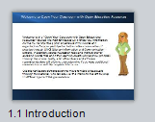
Audio
Text only
Notes to Mike
If the screen needs to be split due to too much text, use 1.1 Welcome continued…

Banner Title | Open Your Classroom to Open Educational Resources
Sub-title | Module 1 – Course Overview
Screen Number | Screen Title
2 | 2.0 Course Outcomes
Lecture/Narrative |  | Visuals
After you complete all the modules in this course you can expect the following:  - You will gain a foundational understanding of Open Educational Resources (OER) and how they can enrich your teaching.  - You will gain search skills to refine search queries, apply appropriate filters, and determine licensing requirements.  - You will learn how to use OER Commons, a repository of educational resources, to find, review, evaluate and save your favorite OER materials.  This course is a prerequisite in a series of courses to help adult education teachers use OER in their teaching. Following is a list of additional courses that you will be prepared to complete:  “Open Science – Open Resources: Engage Adult Learners for 21st Century Skills” This course trains teachers in how to find quality OERs that motivate Adult Education (AE) students and support the development of the Science & Engineering (S&E) Practices as promoted in the Next Generation Standards. It will also provide teachers with ideas and resources for instructional strategies and resources to introduce and engage adult students in learning science.  “Open Math – Open Resources: Engage Adult Learners for 21st Century Skills” is designed to help math teachers find quality OERs for the AE classroom, evaluate them for appropriate classroom use, and assess their effectiveness in meeting learning objectives. It will also provide teachers with ideas and resources for instructional strategies to introduce and engage adult students in learning math.  “Build a Lesson with OER” is a courselet providing resources, presentations and materials to help build your own OER online learning object for your learners using the learning management system Moodle.  As with all learning, you are likely to discover your own cherished nuggets of new-found knowledge. You will be encouraged to share that knowledge with others through the LINCS Community of Practice (LINCS CoP). |  | 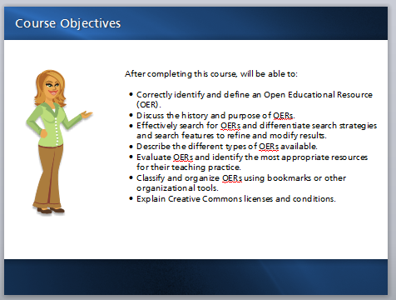
Audio
none
Notes to Developer

Banner Title | Open Your Classroom to Open Educational Resources
Sub-title | Module 1 – Course Overview
Screen Number | Screen Title
3 | 3.0 Posting Reflective Responses in LINCS CoP
Lecture/Narrative |  | Visuals
This self-paced course asks you to be involved in the LINCS Communities of Practice (LINCS CoP) by posting reflective writings on what you learn. As a LINCS member, you are encouraged to join any LINCS CoP that interests you. Simply log in with your username and password to access the 16 communities of practice, called groups. These groups are focused on specific interest areas in our field. You can view these groups at http://community.lincs.ed.gov and join as many as you like.  By posting to LINCS CoP, you not only benefit from feedback from other like-minded educators, you also start to share and gain knowledge and resources on a variety of adult education topics. Although this course will be about Open Educational ResourcesOER, please feel free to explore the LINCS CoP site and groups. |  | Graphic images of LINCS Community groups.
Audio
None
Notes to Developer
Mike: The link above should be live and link to the site in a new window.

Banner Title | Open Your Classroom to Open Educational Resources
Sub-title | Module 1 – Course Overview
Screen Number | Screen Title
4 | 4.0 Hardware and Software Recommendations
Lecture/Narrative |  | Visuals
This course is housed within a course management system called Moodle. If you keep your computer up to date by running the latest updates for your operating system, you likely will have no trouble viewing the materials offered in this course.  However, there are you may need a few software applications that you may need in order to see certain videos, hear audio, or view simulations. Check that your computer has the following applications to ensure ease of use as you continue through the course:  Flash (link to web site) - a video playback program.  QuickTime (link to web site)- a video playback program  Acrobat Reader(link to web site) - opens Portable Document Format (PDF) documents  Java (link to web site) - a software program that runs in the background of many wWeb pages. This program is used to create interactive effects in games, video and other online applications.  System updates - on either Windows or Mac systems, It is important to update both Windows and Mac systems them frequently. For Windows, open the Control panel. Depending on your view, classic or category, choose System>Automatic Updates, or choose Performance and Maintenance> System>Automatic Updates tab. (Be sure the Automatic Updates is not turned off.)  For a Mac, select the Apple icon in the top left corner of your screen and then select "Software update..." and follow the onscreen prompts. |  | 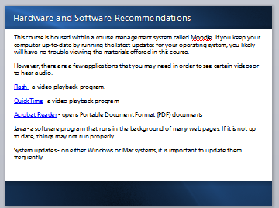
Audio
None
Notes
Mike: The links above should be live and link to the site in a new window.

Banner Title | Open Your Classroom to Open Educational Resources
Sub-title | Module 1 – Course Overview
Screen Number | Screen Title
5 | 5.0 Recommended Browsers
Lecture/Narrative |  | Visuals
The popular browsers (Internet Explorer, Firefox, Chrome, and Safari) work well with Moodle. Be sure to keep these software program up-to-date on your computer and other devices.  Moodle can be accessed through browsers on tablets and on mobile phones. However, those small screens can be difficult to see and to manipulate. If you plan to use other devices such as tablets or smart phones, consider looking in your application store for Moodle applications. These will help to organize information in a way that may be easier to navigate on those devices. |  | 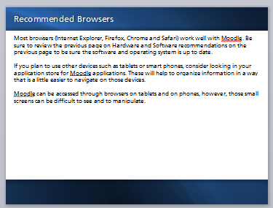
Audio
None
Notes
See screen 4 note.

Banner Title | Open Your Classroom to Open Educational Resources
Sub-title | Module 1 – Course Overview
Screen Number | Screen Title
6 | 6.0 Course Format
Lecture/Narrative |  | Visuals
Course Structure:  The course presents four Modules. In the first three modules, there will be a presentation like this one, with resources, videos or screencasts. Occasionally you are encouraged to take a “self-check” on your learning. These short assessments are meant to be formative and give you guidance in support of your learning.  In some modules, you are asked to post to the LINCS CoP on an aspect of your learning. As mentioned earlier, this will help you summarize your learning, benefit from feedback from other educators, and share knowledge from others about OER and your teaching craft.  You are encouraged to review the modules in sequence. Each builds your knowledge based on what you learned in the previous section. After successfully completing all four modules successfully, you will earn a certificate of completion for the course. Be sure to save this document, as it will provide proof of meeting the prerequisite for the additional courses in this OER STEM series.  The last module is a Course Evaluation. It will gather information on the effectiveness of the course and provide the course developers with feedback for continuous improvement of the course materials. Your feedback is important! Be sure to complete the course evaluation.  Getting Around:  The video on the right will show you how to navigate through this course.  You can control the player by clicking on the "play" and "pause" buttons.  If you need more information, you can search for Moodle tutorials through your favorite search engine or through YouTube. |  | Provide a screen shot of the final course layout.  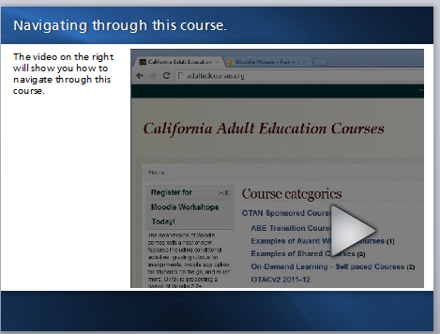
Audio
None
Notes
This screencast needs to be produced after course elements are within the course management system. It needs to look like the course they are in. Design elements (colors, characters etc.) are suggestions only.

The screen cast will review the following: (This information from the course outline.)
- Navigating the Course
- Course home page
- Breadcrumb trail
- Accessing files
- Accessing resources and other learning objects—Commonly used Moodle resources such as Web pages, books, links, assignments, and choice activities
- Learner completion tools; tracking your progress through the course

Suggested Activity: In the “Settings Block” select “My profile settings” then, choose “Edit profile.” Look through the options available and make changes as needed. Be sure to add a description of yourself for others in the course to learn more about you and provide a profile image too.

OCTAE: Are there currently LINCS Learning Portal resources typically used to orient LLP online learners to courses and how Moodle is set up?

Banner Title | Open Your Classroom to Open Educational Resources
Sub-title | Module 1 – Course Overview
Screen Number | Screen Title
7 | 7.0 Check for Understanding
Lecture/Narrative |  | Visuals
To review any items, simply use the menu on the left to return to that section. Select each item below that you have read and understand:  - Course objectives and expected outcomes  - Navigating the course  - LINCS CoP reflective writing  - Hardware/software requirements and recommended browsers |  | 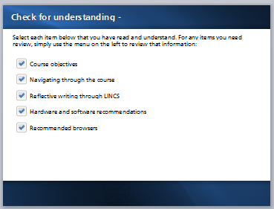
Audio
None
Notes to Developer
Users should select all items; if they do not, feedback should provide prompt to return to that section and review the materials. “It looks like you missed one. Be sure to click on the menu item on the left to review that section.” (If we can make the feedback specific for each section that would be nice.)

Banner Title | Open Your Classroom to Open Educational Resources
Sub-title | Module 1 – Course Overview
Screen Number | Screen Title
8 | 8.0 Next Step
Lecture/Narrative |  | Visuals
You have completed Module 1! Congratulations!  Next, be sure to take the short self-assessment quiz. It offers a series of questions on the topics covered throughout this course. Do not expect to know all the answers! Just make your best effort. As you progress through the course, feel free to try the quiz again. (It has many questions so you may not see the same question twice – unless you take it repeatedly.) The quiz will ask questions about your knowledge of OER Open Educational Resources, licensing and Creative Commons, searching techniques and more.  After you close this activity, be sure to mark it “complete” on the course home page. |  | Checkered flag – graphic to indicate finishing and text.  Graphic of the Completion check-box in Moodle.
Audio
None
Notes to Developer

